Chromosome-Related Design
This section describes how the stock cutting problem is represented in terms of shapes, genes and chromosomes. Following this genetic operators, which manipulate existing chromosomes to generate new chromosomes, are discussed.

Shape Storage
There is exactly one n element array, called the shape group, which stores all shape specifications for cutting.

Shape Class
One element in this array is called a shape and holds the following specifications:
- integer width (x_size)
- integer height (y_size)
- shape identifier (id – integer in range 0 to n-1)
- boolean rotation flag (rotation_ok)

It is a requirement that all shapes have x_size and y_size smaller than the stock-sheet width and height, respectively. The id uniquely labels each shape in the shape group. The first shape in the shape group is assigned zero id. Ids increase incrementally along the shape group array. Rotation_ok is true if the shape, when rotated by 90 degrees, fits on an empty stock sheet. The shape class also provides a stream-input function which allows shape dimensions to be read from a file. Streamed input should be in the format: <x_size> <y_size>, with each field separated by white space.

Shape Group Class
The shape group offers the following services:
- can provide the length of the shape array
- a single shape array element can be accessed using the [] operator
- set_rotation_validities function – provided with the width and height of the stock-sheet, this function updates the rotation_ok flags of all its shape in the shape group.

Gene and Chromosome Representation
In general. a chromosome has n genes. The chromosome class is a base for creating the specialised derivative, LDA_chromosome class. The gene class is a base for creating the specialised derivative, shape_gene class. The base classes contains pure virtual functions which are pertinent to any specialised chromosome or gene that the programmer may wish to write. Derived classes override functions in the base class with code specific to the problem domain. This allows other parts of the application to interact with all types of chromosome in an identical way.

Most of the functions in the base classes are pure virtual which means they contain no code. These require a derivative class to provide code for these functions. The role of the base class is to define the interface for all its derivative classes. Some functions in the chromosome class are non-pure virtual and so do not have to be overriden. As the chromosome and gene classes contain pure virtual functions, objects of type chromosome and gene cannot be instantiated.

Gene Class (base)
The following services are defined in the gene class interface and all derivatives of this class must supply code to implement these:

- create – returns a pointer to a newly allocated gene, which has identical type to the gene used to call this function. The data in the new gene is not set
- clone – same as create, except the data in the new gene is an exact copy of the data in the gene used to call this function
- get_gene_id – returns the id of the gene
- gene copy – given a pointer to a source gene, the contents of the source gene is duplicated in the gene used to call this function
- copy feature 1 – same as gene copy, except only feature 1 is copied
- copy feature 2 – same as gene copy, except only feature 2 is copied
- copy all features – same as gene copy, except only features 1 and 2 are copied
- randomize feature 1 – change feature 1 in a random way
- randomize feature 2 – change feature 2 in a random way
- randomize all features – change features 1 and 2 in a random way

The copy feature operations are used by crossover operators, and the randomize feature operations are used by mutation operators. The create and clone operations are used to generate new genes with identical type to the calling gene.

Shape_gene Class
A single shape_gene contains the following data items:

- a shape pointer (p_piece)– points to a single shape in the shape group to be laid out
- Feature 1: an orientation boolean – signifies whether the shape is rotated 0 or 90 degrees
- Feature 2: a heuristic setting – enumerated type which instructs the layout determining algorithm to place the shape using a particular heuristic

All the functions in the gene class are overriden appropriately. The get_gene_id function returns the id of the shape being pointed to by p_piece. Randomizing feature 1 involves setting the orientation to either 0 or 90 degrees randomly. Randomizing feature 2 involves setting the heuristic to : LEFTMOST, TOPMOST, ILEFTMOST or ITOPMOST. These heuristics will be explained later.

Chromosome Class (base)
The chromosome class encapsulates an ordered sequence of gene-type objects. The following services are defined in the chromosome class interface and all derivatives of this class must supply code to implement these:

- create – returns a pointer to a newly allocated chromosome, which has identical type to the chromosome used to call this function – the data in the new chromosome is not set
- create_array – same as create, except an entire array of chromosomes is allocated – this is used by the population class
- create_loaded_array – same as create_array except the pointer to a source array of chromosomes is provided, and this is used to supply gene data for the new chromosome array
- clone – same as create, except the data in the new chromosome is an exact copy of the data in the chromosome used to call this function – that is, all genes are copied
- chromosome copy – Given a pointer to a source chromosome, the contents of the source chromosome is duplicated in the chromosome used to call this function.
- size_of – returns the number of bytes used to store the chromosome
- single gene element access using the [] operator
- fitness – returns the cached fitness value for the chromosome if the invalidate_fitness function has not been called – otherwise, if the invalidate_fitness function has been called, the fitness value is recalculated before being returned
- invalidate_fitness – called when the genes of a chromosome have been changed in some way, requiring the cached fitness value to be re-calculated next time fitness function is called.
- init_chromosome – fills the genes in the chromosome with fixed, meaningful data
- random_chromosome – randomizes the gene data in the chromosome
- ordered_chromosome – sets the gene data in the chromosome to a particular setting
- get_permutation – Given a pointer to an array of integers, an ordered sequence of gene_ids are stored, corresponding to the order of the genes in the chromosome.
- get_permuation_char – Same as get_permutation except a character array pointer is provided and data is stored in a format suitable for outputting to the screen.
- get_length – returns the number of genes in the chromosome
- distance – Provided with a chromosome pointer, this function compares the supplied chromosome and the chromosome used to call this function, returning the hamming distance between the two.

LDA_chromosome Class
An LDA_chromosome has exactly n shape_genes where each gene uniquely refers to a single shape and all shapes are derived from exactly one shape group. The LDA_chromosome represents an ordered permutation of shapes, where each shape must be referenced exactly once. Each shape_gene carries orientation and heuristic data which instructs the layout determining algorithm how to place the shape.

Each LDA_chromosome contains cached fitness data which corresponds to the current fitness of the chromosome. If the chromosome is changed in any way, the code responsible for the change calls invalidate_fitness. This directs the fitness to be re-evaluated on the next occasion fitness data is requested from the chromosome. Caching fitness data increasing efficiency as fitness doesn’t get re-evaluated if the chromosome hasn’t been modified.

The distance function for LDA_chromosome compares the gene_id sequencing of the supplied chromosome and the calling chromosome. Distance begins at zero and is incremented for every mismatched gene_id. For example, if two genes place the same 5 shapes in the same order, but then place another 6 shapes in disparate order, then distance is calculated as 6.

All LDA_chromosomes share a static connection to an LDA_environment which contains the layout algorithms. This allows LDA_chromosomes to evalutate their own fitness and initialise themselves to a random permutation or pre-determined permutation. Fitness, init_chromosome, random_chromosome and ordered_chromosome, get_permutation and get_permutation_char function calls are processed indirectly by the LDA_environment.

All LDA_chromosomes also share a static length variable which sets the length of all LDA_chromosomes. The length corresponds to the number of shapes that are to be placed on the stock-sheet.

Gene and Chromosome Representation Summary
An LDA_chromosome consists of a permutation of shape_genes. Each shape_gene refers to one shape in a common shape group. Each shape_gene can determine the shape’s orientation and placement heuristic. Chromosome fitness is calculated by an LDA_environment which is common to all LDA_chromosomes.

Genetic Operators - Crossover
These operators take features from two parents to generate a child, whilst maintaining the permutation property of the chromosome. Each operator is encapsulated in a class of its own, which is derived from the crossover class.

Crossover Base Class
All crossover operator classes are derived from the crossover base class. The class defines the interface for all crossover operators. All crossover classes have a name string used to identify the crossover operator. The interface requires the following functions:

- cross function – supplied with pointers to parent one, parent two and child chromosomes. Note that the cross function does not allocate memory for the child. The cross function performs the crossover operation pertinent to the class.
- clone function – returns a pointer to a new crossover-type object which has identical derived-type and data as that of the crossover object used to call the clone function

Order-based Crossover – order_c class
This operator selects a random collection of genes from parent 2. The allele-order of these genes is noted. The child is made identical to parent 1, except those alleles selected in parent 2 are reordered in the child according to their order in parent 2.

In the example below, the 1s in the selection mask label chosen genes, digits in the chromosome sequences represent gene-ids (allele data) for each gene, and underscore & italic are used to hilight genes.

Choose genes 0, 1, 3, 5 by location in parent 2: 1 1 0 1 0 1 0 (Selection Mask)
Chosen genes contain alleles 4, 3, 2, 1 in parent 2: 4 3 0 2 5 1 6 (Parent 2 chromosome)
These alleles are affected in parent 1: 6 5 1 2 0 3 4 (Parent 1 chromosome)
The child contains a copy of parent 1,
where affected alleles are reordered
according to the order that they appear in parent 2 : 6 5 4 3 0 2 1 (Child chromosome)

A summary of the algorithm is as follows:

(Step 1) A random number of genes are chosen from parent 2 - the allele order is noted.
(Step 2) FOR all genes (i) in parent 1:
IF gene i in parent 1 contains an allele which isn’t in one of the chosen genes
copy the allele in gene i of parent 1 to gene i of the child,
ELSE
get next uncopied allele in ordered set of chosen genes from parent 1
copy this allele to gene i of the child.

Segmented Order-based Crossover – seg_order_c class
This operator is identical to the order-based crossover, except that:
- the number of genes selected in the selection mask is randomly chosen between a minimum and a maximum setting
- these chosen genes form a continuous segment, eg. 0 0 1 1 1 0 0, has a segment length of 3.

By preserving segments of chromosome, this operator may be more successful than the standard order-based crossover.

Position-based Crossover – position_c class
This operator selects a random collection of genes from parent 2. These genes have their alleles copied directly into the corresponding genes in the child. Remaining genes in the child are filled in-order with alleles that haven’t yet been copied, by scanning genes in-order from parent 1.

In the example below, the 1’s in the selection mask label chosen genes, digits in the chromosome sequences represent gene-ids (allele data) for each gene, and underscore & italic are used to hilight genes.

Choose genes 2, 3, 4, 6 by location in parent 2: 0 0 1 1 1 0 1 (Selection Mask)
Chosen genes contain alleles 4, 7, 6, 3 in parent 2: 1 2 4 7 6 5 3 (Parent 2 chromosome)
These genes are copied from parent 2 to the child: - - 4 7 6 - 3 (Child incomplete)
Genes to be copied, preserving order, from parent 1: 6 1 5 4 3 7 2 (Parent 1 chromosome)
Result after copying genes from parent 1 to child: 1 5 4 7 6 2 3 (Child complete)

A summary of the algorithm is as follows:

(Step 1) A random number of genes are chosen from parent 2.
(Step 2) FOR all genes in the set of chosen genes (i):
copy gene i of parent 2 to gene i of the child
(Step 3) FOR all genes (j) in parent 1:
IF allele in gene j is NOT already in child
copy gene j into the leftmost unoccupied gene in the child *
ELSE
skip this iteration

* leftmost unoccupied gene – the leftmost gene in the child chromosome that has yet to be copied into.

Segmented Position-based Crossover – seg_position_c class
This operator is identical to the position-based crossover, except that:
- the number of genes selected in the selection mask is randomly chosen between a minimum and a maximum setting
- these chosen genes form a continuous segment, eg. 0 0 1 1 1 0 0, has a segment length of 3.

By preserving segments of chromosome, this operator may be more successful than the standard position-based crossover.

Half-uniform Crossover – HUX_position_c class
This crossover operator is identical to segmented position-based crossover, except the segment is either the first half or the second half of the chromosome.

Edge-Recombination Crossover – edge_recombination_c class
The child chromosome is derived from the two parents as shown in the following example:

- Build Edge Map for parent1 (3716524):
The edge map shows the ‘edges’ or ‘neighbours’ associated with each allele. The allele is defined as the gene-id of each gene. The chromosome is treated as circular, hence the neighbours of the ‘3’ allele are 4 and 7.
Alleles: 1 2 3 4 5 6 7
Edges: 6,7 4,5 4,7 2,3 2,6 1,5 1,3

- Build Edge Map for parent2 (2761534):
Alleles: 1 2 3 4 5 6 7
Edges: 5,6 4,7 4,5 2,3 1,3 1,7 2,6

- Combine the two Edge Maps:
Alleles: 1 2 3 4 5 6 7
Edges: 5,6,7 4,5,7 4,5,7 2,3 1,2,3,6 1,5,7 1,2,3,6
- Pick random parent for first allele of child and remove allele 3 from edge map:
Child: 3******

Alleles: 1 2 3 4 5 6 7
Edges: 5,6,7 4,5,7 4,5,7 2 1,2,6 1,5,7 1,2,6
- Find edge map for current allele, 3: 4,5,7 – choose allele with smallest no. of edges (4), and remove allele 4 from edge map.

Child: 34*****
Alleles: 1 2 3 4 5 6 7
Edges: 5,6,7 5,7 5,7 2 1,2,6 1,5,7 1,2,6

- Find edge map for current allele, 4: 2 – choose allele with smallest no. of edges (2), and remove allele 2 from edge map.

Child: 342****
Alleles: 1 2 3 4 5 6 7
Edges: 5,6,7 5,7 5,7 1,6 1,5,7 1,6

- Find edge map for current allele, 2:5,7 – choose allele with smallest no. of edges (randomly choose, say 7), and remove allele 7 from edge map.

Child: 3427***
Alleles: 1 2 3 4 5 6 7
Edges: 5,6 5 5 1,6 1,5 1,6

- Find edge map for current allele, 7:1,6 – choose allele with smallest no. of edges (randomly choose, say 1), and remove allele 1 from edge map.

Child: 34271**
Alleles: 1 2 3 4 5 6 7
Edges: 5,6 5 5 6 5 6

- Find edge map for current allele, 1:5,6 – choose allele with smallest no. of edges (randomly choose, say 5), and remove allele 5 from edge map.

Child: 342715*
Alleles: 1 2 3 4 5 6 7
Edges: 6 6 6

- Find edge map for current allele, 5:6 – choose allele with smallest no. of edges (6), and remove allele 6 from edge map.

Child: 3427156
Alleles: 1 2 3 4 5 6 7
Edges:

Designed for the Travelling Salesman Problem, this operator is good at preserving edges – ie keeping together groups of alleles. However, there are two ways that an edge can be preserved and it remains to be seen if this operator will work well with the stock-cutting problem. This is because both groups of alleles and their order need to be preserved in the stock-cutting problem.

N-point Feature Crossover – n_point_c class
All the crossover operators discussed so far have combined characteristics of the gene permutations present in both parents. This crossover operator performs an n-point crossover on either feature 1, feature 2, or both features of both parents. Feature 1 corresponds to the orientation flag and feature 2 corresponds to the heuristic setting in each shape_gene.

The class has two parameters controlling the crossover:
- N_point – sets the number of crossing points
- copier function pointer – sets the copy function to be used, either feature_1, feature_2 or all_features

The child is first created from a clone of parent 1. The crossover operation then affects only the features specified in the copier parameter.

Genetic Operators - Mutators
These operators make changes to a single chromosome, whilst maintaining the permutation property of the chromosome. Each operator is encapsulated in a class of its own, derived from the mutation class.

Mutation Base Class
All mutation operator classes are derived from the mutation base class. The class defines the interface for all mutation operators. The following data members are common to all mutation classes:
- name string – identifies the type of mutator by an alphanumeric name
- in_situ_mutation – boolean indicating whether mutation should occur within the parent chromosome itself, or whether a separate child chromosome should store the result
- finished – boolean set by mutation operators which have state
- restart – boolean set by mutation operators which have a restart status

The finished and restart flag are not used by the mutation operators described here. They are used in simulated annealing and hill climbing which is covered in a later section.

The mutation class interface requires the following functions:
- mutate– supplied with pointers to parent one and child chromosomes. Note that the mutate function does not allocate memory for the child. The mutate function performs the mutation operation pertinent to the class.
- clone– Returns a pointer to a new mutation-type object which has identical derived-type and data as that of the mutation object used to call the clone function.
- reset_mutator – Performs any initialisation, eg used to reset the temperature variable in simulated annealing.

The following function is defined for the mutation class:
- set_in_situ_mutation – determines whether the mutation operation occurs in the parent or in a child copy of the parent. In-situ mutation is possible when performing simple mutations, such as swap mutations.

Single-gene Swap Mutation – swap_m class
This operator picks one pair of genes at random and swaps their locations in the chromosome.

Multiple-gene Swap Mutation – multiple_swap_m class
This operator picks n pairs of genes at random and swaps their locations in the chromosome. The operator guarantees that any single gene can change position a maximum of once. The operator can be provided with the value for n or a percentage corresponding to the amount of the chromosome to be mutated. For example, swapping 25% of chromosome corresponds to 5 swaps (each involving two genes) in a 40-gene chromosome.

Inversion Mutation – invert_m class
This operator first selects two sentinel genes in the chromosome. The string of genes between and including the sentinel genes have their ordering in the chromosome reversed. The example in Figure 1 shows the inverted string italicised, where the chromosome is a permutation of 10 shapes, labelled ‘0’ through ‘9’.

Parent: 0 1 2 3 4 5 6 7 8 9 Sentinel genes: 4, 7
Child: 0 1 2 3 7 6 5 4 8 9
Figure 1. Example of inversion mutation.

Shunt Mutation – shunt_m class
This operator first selects two sentinel genes in the chromosome. A third gene is chosen as an insertion location. The string of genes between and including the sentinel genes is moved to the insertion location in the chromosome. Genes not in this string are shunted to make room
for the string. The example in Figure 2 shows the shunted string italicised, where the chromosome is a permutation of 10 shapes, labelled ‘0’ through ‘9’.

Parent: 0 1 2 3 4 5 6 7 8 9 Sentinel genes: 4, 7 insertion gene: 1
Child: 0 4 5 6 7 1 2 3 8 9
Figure 2. Example of shunt mutation.

Standard Mutation – standard_m class
This mutation class makes random changes to the features (ie orientation and/or heuristic settings) pertaining to a fixed number of randomly picked genes in the parent chromosome. It has two parameters:
- Gene count – determines the number of genes to randomize.
- randomizer function pointer – determines the randomization function to use: randomize_feature_1, randomize_feature_2 or randomize_all_features.

Feature 1 corresponds to the orientation flag. Feature 2 corresponds to the heuristic setting.

Cataclysmic Mutation – cataclysmic_m class
This mutation operator is applied to an entire population of chromosomes, instead of individual chromosomes. The fittest chromosome is left untouched by this operator. All other chromosomes are mutated by a percentage, such as 35%. This is achieved using the Multiple-swap Mutator. For example, if the chromosome length is 100 and mutation percentage is 35%, then the number of swaps required is 17.5 – which is rounded down to 17. Thus, in total, 34 genes are swapped.

This mutation operator has a single parameter:

- mutate_features – boolean which signifies whether orientation and heuristic settings should be mutated, in addition to the gene permutation.

The cataclysmic mutator uses a standard mutation object (called feature_mut) to perform feature mutation. If feature mutation is required, then the randomizer parameter of the feature_mut has to be set appropriately.

As the cataclysmic mutation operator does not operate on single chromosomes, the standard mutate function performs no operation. In order to apply this operator to a population the following function is called:

- global_mutate – requires both a pointer to the population to be mutated and the percentage change required (supplied as a floating point number in the range 0 to 1, where 0 is no change and 1 is 100% change) to be provided.

Environment-Related Design
The following sections describe the layout determining algorithm §2.1 and the environment classes, §2.2 and §2.3, which allow the LDA to be used with the GA. Terminology is grouped in sections, which are situated in places where further explanation is required.

Layout Determining Algorithms

Introduction
Let us suppose that we have an algorithm for placing individual shapes on the sheet, called the Layout Determining Algorithm (LDA). The LDA’s job is to place single shapes in positions which favour efficient sheet usage.

A very simple LDA (equivalent to the level-oriented Next-Fit First Descending algorithm) builds its shape layout in columns. Figure 3 illustrates the layout of eleven shapes on a stock-sheet with dimensions x-size by y-size. Starting from the left side of the sheet, columns abut across the sheet. A single column is built from the top of the sheet to the bottom. A column’s height accumulates as shapes are added to the bottom of the column by the LDA. A column’s width is equal to the width of the widest shape in that particular column. Once a column grows too far down the sheet, such that the next shape will not fit between the bottom of the column and the bottom of the sheet, a new column is started to the right of the old column.

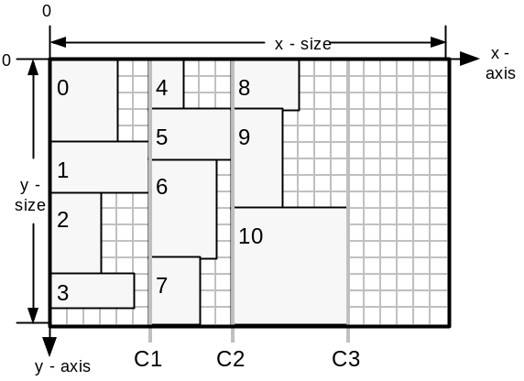
Figure 3.The layout of 11 items using the simple LDA. Annotation numbers signify order with which shapes were placed, beginning with zero. Column boundaries are labelled C1, C2 and C3. Column width is set by the widest shape in the column. The scale for all layout diagrams is a grid-square is one logical coordinate high and wide.

Terminology (Part 1)
Examples of how the terminology (italicised) is used to describe the relative positions of shapes throughout this project (referencing Figure 3):
- shape 0 is behind shapes 4 and 5
- shape 8 is in-front-of shape 4
- shape 4 is above shape 5
- shape 5 is below shape 4
- the placement position of shape 0 is (0,0) (Top-left vertex)
- the x-offset of shape 1 is 0 (x component of placement position)
- the y-offset of shape 4 is 0 (y component of placement position)
- the top- and bottom-faces of shape 0 are on the lines x=0 and x=5, respectively
- the left- and right-faces of shape 0 are on the lines y=0 and y=4
- the sheet has an area of x-size . y-size

In more advanced LDAs, heuristics are used to direct shape placement. A typical placement heuristic is to place a shape in the ‘leftmost’ area of the sheet which is entirely unoccupied by any previously placed shapes. A ‘topmost’ heuristic would operate in a similar way. A possible regime for placing shapes would be to alternate between these two heuristics, beginning with say ‘leftmost’.

Consider a regime where the ‘leftmost’ heuristic is always used. The sheet would get filled-up in a sweep from left to right, building in an approximate columnar arrangement from top to the bottom of the sheet. If there are two positions which are equally ‘leftmost’ then the LDA favours the position which is ‘topmost’ out of these two.
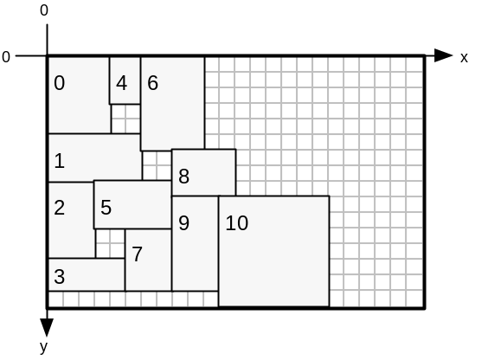
Figure 4. A greedy placement algorithm uses the ‘leftmost’ heuristic to layout the shapes used in Figure 3.
A regime which always uses the leftmost heuristic may favour placement of narrow, tall shapes. It may be biased against wide, short shapes due to the columnar construction of the layout. The same argument applies to a constant ‘topmost’ regime.

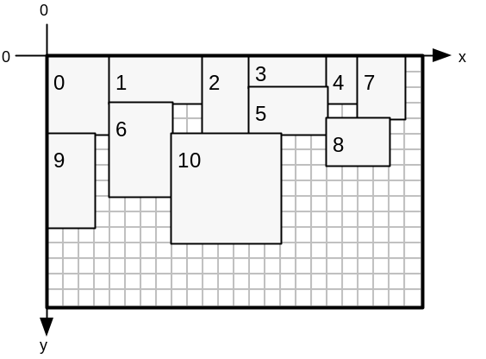
Figure 5. A greedy placement algorithm uses the ‘topmost’ heuristic to layout the shapes used in Figure 3.
Alternating the regime favours neither row or column building, so may be more capable of searching a large search space.

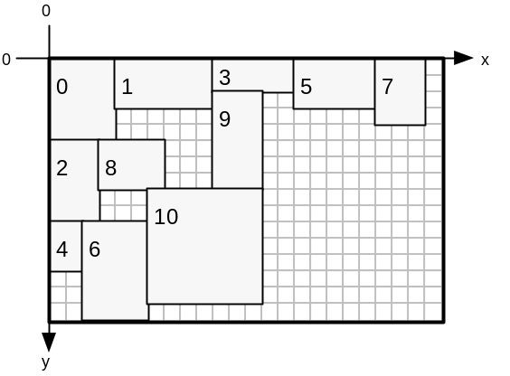
Figure 6: A greedy placement algorithm alternates between leftmost and topmost heuristics, beginning with leftmost, to layout the shapes used in Figure 3
Alternatively, a refinement to flipping between ‘leftmost’ and ‘topmost’ is to store a heuristic inside every shape_gene. The LDA would then extract the heuristic setting from the shape_gene before placing the corresponding shape. This dynamic regime would offer the chromosome three methods for diversifying:

- Exploring permutations of shape_genes
- Manipulating the orientation flag of each shape_gene
- Manipulating the placement heuristic of each shape_gene

To summarise, the simplest placement regime is to place all shapes ‘leftmost’ or ‘topmost’. This may be refined to alternating the heuristic between ‘leftmost’ and ‘topmost’, providing a more balanced placement mechanism. This may be further refined by allowing individual shape_genes to dictate individual placement heuristic, enabling the GA to evolve its own dynamic placement regime. An example dynamic regime consisting of five shapes is: left, top, top, left, top.

LDA Features – Overview
The LDA’s purpose is to make the search-space of possible layouts smaller. Erroneous layouts with overlapping shapes are eliminated from the search-space by using the LDA. This makes the GA more likely to find a good optimisation. Without the LDA, the GA would initially create random locations, in 2-dimensions, for the shapes. Overlapping shapes would be inevitable and layouts with at least one pair of overlapping shapes would form the majority of the search-space. Layouts with zero overlapping pairs would be sparsely scattered throughout the search-space, resulting in unfeasible conditions for evolving a good solution.

The LDA developed keeps track of the convex area encompassing free-space on a sheet. Placing a shape involves the LDA searching for sufficiently sized gaps in free-space in which the shape may fit. A choice is then made as to which gap to use, directed by the placement heuristic. A record of currently placed shapes and their locations is kept, whilst the free-space representation is updated on each placement. The LDA places all shapes in the order described by a chromosome, and subsequently calculates fitness metrics for the layout. These are then used to direct selection operators in the GA. The use of an LDA reduces the optimisation from a 2-dimensional problem to a 1-dimensional permutation-based one.

The LDAs designed for this project have the following features:
- Layout: A record of which shapes have been placed where on the sheet. Allows the entire layout to be examined once all shape_genes in a chromosome have been placed.
- Free-Space Representation: Used to determine where in the current sheet new shapes can be placed.
- Placement Builder: An analyser for (2) which yields all possible placement positions for a particular shape.
- Placement Chooser: Picks a single placement position from (3) which satisifies the current placement heuristic, say ‘leftmost’.
- Free-Space Updater: Adjusts (2) to take account of a newly placed shape.
- Layout Updater: For adding the shape and its location to (1)
- Sheet Creator: Processes the situation where the current sheet has insufficient space to place the next shape, in where (3) yields no placement positions.
- Fitness Evaluator: Returns fitness value for the current layout corresponding to how efficiently sheets are used. This is calculated by considering the final state of (2) after all shape_genes in the LDA_chromosome have been placed.

The following section details design and implementation issues for each of these features.

LDA Features – Design and Implementation

Layout
This is a record of which shapes have been placed where on the sheet. This allows the complete layout to be analysed after all shape_genes in a chromosome have been processed.

To satisfy this, an array of ‘layout_pieces’ is used. A single layout_piece contains:
- a copy of the shape_gene enhanced with an (x,y) placement coordinate, encapsulated into a shape_gene_l object
- a boolean (new_sheet_needed) which is true if the layout_piece requires a new blank sheet to be used.

The first element in the layout_piece array always has its boolean set to true. If all shapes in the chromosome have been placed onto a single sheet then all other layout pieces in the array have their booleans set to false. If the xth layout_piece cannot fit on the current sheet its boolean is set to true and an additional sheet is created for placement of the xth shape and any other unplaced shapes. As many sheets as are required are created as each sheet becomes full. Layout_pieces which fit on the current sheet have their boolean set to false.

Free-Space Representation

Introducing the left-profile
This representation is used to determine where in the current sheet new shapes can be placed. Firstly, we shall consider a representation which can work with the leftmost heuristic. The free-space representation trades-off completeness against computational complexity, and is required only to describe a ‘good’ proportion of the free-space available for new shapes.
Figure 7 illustrates a representation for free space. All shapes have been placed using the leftmost heuristic.
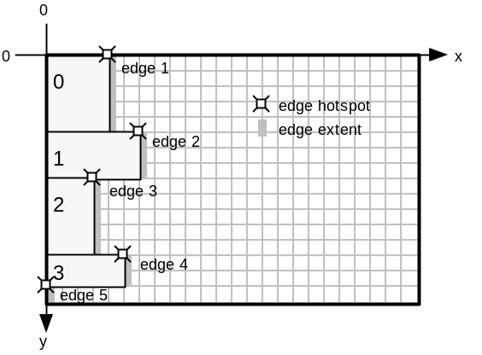
Figure 7. A representation for describing a convex outline of the free space remaining on the sheet.
An ‘edge’ exists wherever a shape has a segment of its right-face in line-of-sight (in a direction along the x-axis) with the right-face of the sheet. Each edge has a length (equal to the segment length) and an (x,y) coordinate corresponding to the edge’s upper-extent, known as the hotspot – marked with ‘’ in the figure. Edges are stored in a linked list of edge nodes where nodes are ordered according to increasing y location of hotspot, y-edge-offset. This edge list is know as the left-profile. The left-profile maintains the list of edges which defines the left-most limit of the free space available on the sheet. No two edges may overlap in the y-axis, and the left-profile represents the entire extent of the y-axis without discontinuity. The total length of all edges in the edge list is equal to the height of the sheet (the y-size of the sheet).

Figure 8 illustrates how both the current layout and the left-profile is updated as each shape is added to the layout, using a leftmost placement heuristic.

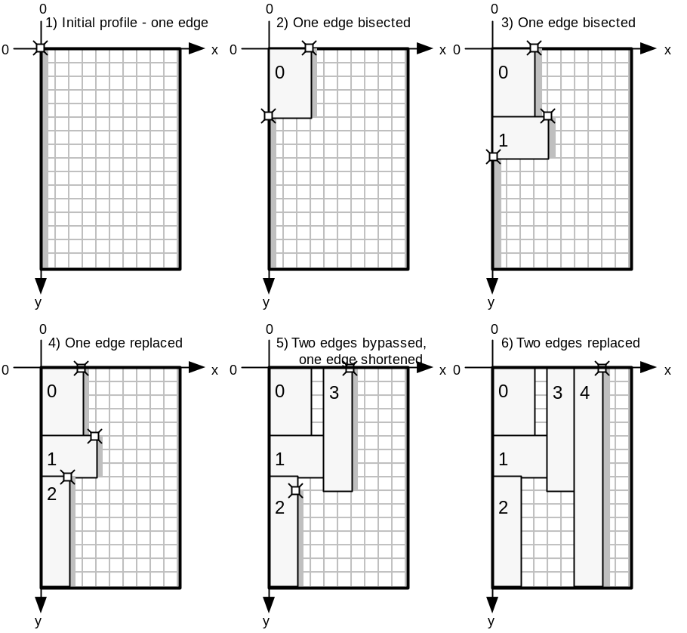
Figure 8. Layout construction and left-profile update illustration. In step 1, no shapes have been placed yet and there is one edge (hotspot=(0,0); length=y-size). Adding shape 0 and shape 1 both result in a single edge being bisected. Adding shape 2 results in an edge having its x location of hotspot, its x-edge-offset, increased by the width of the placed shape. Adding shape 3 bypasses edges 1 (top edge) and 2, whilst displacing and shortening edge 3. Adding shape 4 bypasses both remaining edges with a single edge equal in length to sheet y-size.

Limitations of the left-profile
The left-profile is good for placing shapes using the leftmost heuristic. However, when using a topmost heuristic areas of free-space are masked, making them unavailable for placement. Figure 9 shows how successively top-placed shapes mask areas behind the left-profile.
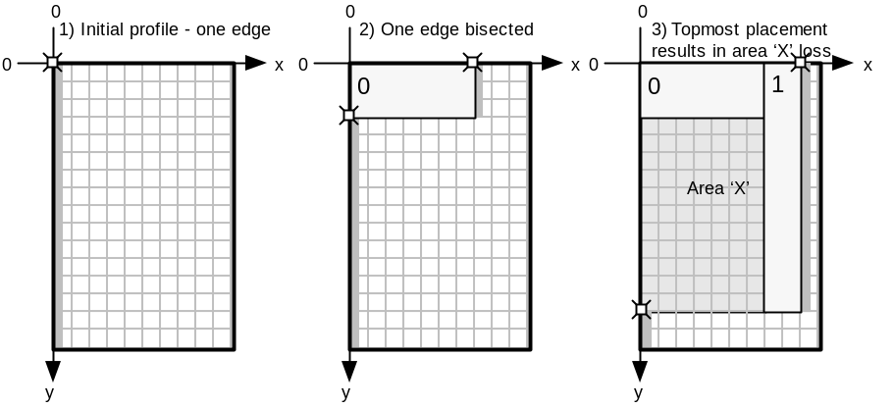
Figure 9. The addition of shape (1) in step (3) renders area ‘X’ invisible to the left-profile.This area is lost from the free-space representation. Invisible areas make it harder for the LDA to create efficient layouts. Free-space is masked from the left-profile when there is a shape to the right of the free-space.

Overcoming left-profile limitations – introducing the top-profile
The top-profile is a method by which free-space may be represented more effectively when used in-conjunction with a left-profile. Figure 10 illustrates the top-profile representation. All shapes have been placed using the topmost heuristic.
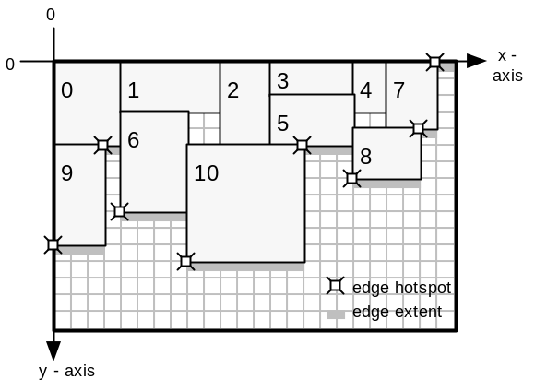
Figure 10. Top-profile is equivalent to left-profile rotated through 90 degrees. An edge hotspot corresponds to the left-extent of the corresponding edge, and edge length is measured in the x-axis. Edges are ordered according to increasing x-edge-offset in the top profile. The top-profile defines the topmost limit of the free space available on the sheet and considers the positioning of the bottom-faces of placed shapes. This is in contrast to the left-profile, which considers right-face positioning. The total length of all edges in the top profile edge list is equal to the width of the sheet (the x-size of the sheet). Before any shapes are placed, the top profile consists of a single edge (hotspot=(0,0); length=x-size), which spans the x-axis.

Top-profile is good for placing shapes using the topmost heuristic alone. Using the leftmost heuristic, with the top-profile representation, results in area masking as illustrated in Figure 11.
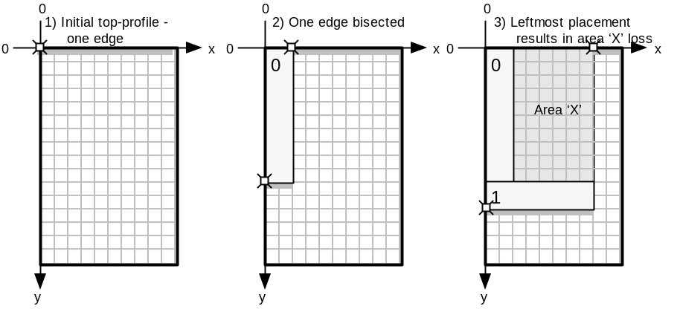
Figure 11. The addition of shape (1) in step (3) renders area ‘X’ invisible to the top-profile. This area is lost from the free-space representation. Invisible areas make it harder for the LDA to create efficient layouts. Free-space is masked from the top-profile when there is a shape below the free-space.
Once an area becomes masked it is no longer represented by any of the edge profiles. This restricts the number of places that the LDA can fit shapes. Although the space may be free, when masked from all profiles it cannot be utilised, so it is wasted reducing fitness.

Combining both left- and top-profiles
By using both a left-profile and a top-profile (independent of each other), a free-space representation better than either of these methods alone is possible. Using this dual-representation allows the previously masked ‘X’ areas in both Figure 9 and Figure 11 to be represented as free-space. When using the left-profile alone, free-space is masked when there is a shape to the right of the free-space. Similarly, when using the top-profile alone, free-space is masked when there is a shape below the free-space. The advantage of using the dual-representation is that only the free-space that has both a shape to its right and a shape below becomes masked. Figure 12 (parts (a) and (b)) shows how the final layouts in Figure 9 and Figure 11 are represented using two profiles – the shaded areas are no longer masked. Part (c) of Figure 12 illustrates the limiting case where a free-space area has both a shape to its right and a shape below it.

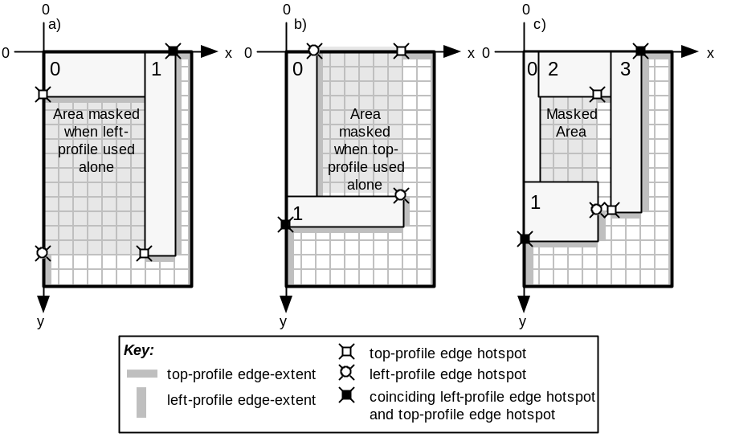
Figure 12. (a) Layout from Figure 9, step (3). The dual-representation prevents the shaded area from being masked, whereas it is in the left-profile only case. (b) Layout from Figure 11, step (3). The dual-representation prevents the shaded area from being masked, whereas it is in the top-profile only case. (c) This layout has been placed using a top-left heuristic, beginning with topmost, and illustrates the limitation of the dual-representation. The masked area cannot be represented by either the left-profile or the top-profile and so is unavailable free-space.
It is thought only a complete constrained-polygonal representation can improve upon the dual-representation. The ‘constrained’ polygon would be composed of lines parallel to one of the axes. This representation would be considerably more complex and so we return to the completeness against complexity tradeoff that exists when designing the free-space representation. A constrained-polygonal representation would not use the profile concept at all and would treat the limiting case, as in Figure 12(c), as a single polygonal area – see Figure 13.
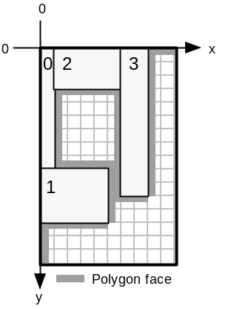
Figure 13.A polygonal representation of free-space. Placing a shape would require testing each polygon vertex and then checking if other vertices interfere with the shape placement.

The advantage of this representation is that any ‘holes’ (free-space completely surrounded by placed shapes) developed in the layout can be represented as additional constrained-polygonal free-space areas. There is no method to make holes in the single- or dual-representations available for shape placement. It is the job of the GA to fill holes by evolving a suitable permutation which prevented hole creation in the first place.

To conclude this section, the dual-representation has been chosen as it allows a fairly complete representation of free-space, without being overly complex.

Comparison of algorithms between left- and top-profile functions
Manipulating the top-profile requires the same algorithms as for the left-profile, except all references to a particular axis are switched to the opposite axis. The parallel axis refers to the axis parallel to the direction of an edge in a profile. The orthogonal axis refers to the axis orthogonal to the direction of an edge in a profile. Algorithms may be coded in terms of operations working with parallel and orthogonal axes, allowing them to work with both left- and top-profile, given appropriate initial settings according to the profile being manipulated. The differences are summarised in Table 1.

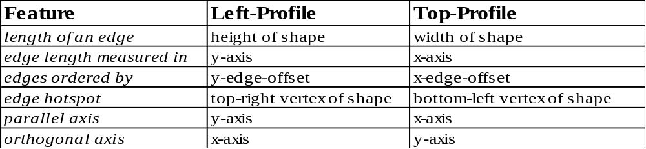

Table 1. Differences between left-profile and top-profile.

The parallel/orthogonal axis terminology is good for coding the algorithms, but is not convenient for describing the algorithms. The code proves that the algorithms for both profiles are the same, except for the initialisation stage where the meanings of parallel and orthogonal axis are set according to the profile being updated. The algorithms are described for the left-profile only, using the appropriate x/y axis terminology, to provide clarity.

Terminology (Part 2)
For left-profile:
- an edge corresponds to the right-face of a shape
- the edge hotspot describes the location of the upper-extent of a left-profile edge
For top-profile:
- an edge corresponds to the bottom-face of a shape
- the edge hotspot describes the location of the left-extent of a top-profile edge.
For both profiles:
- the y-edge-offset of an edge corresponds to the y component of the edge hotspot
- the x-edge-offset of an edge corresponds to the x component of the edge hotspot
- the parallel axis is the axis which is parallel to edges in the profile
- the orthogonal axis is the axis which is orthogonal to edges in the profile

Placement Builder
The placement builder analyses the free-space representation and yields all possible placement positions for a particular shape.

All locations in the left-profile where a single new shape can be placed without overlapping existing shapes in the layout and without overlapping the edges of the sheet are placed into an array of coordinates called left-places. Locations found in the top-profile are added to the top-places coordinate array. The algorithm below is for extracting locations from the left-profile.

FOR all edges (n) in the profile:
LET current_edge=edge_n
LET accumulated_length=current_edge.length
LET fit_location=current_edge.hotspot
label1:
IF new_shape.height > accumulated_length THEN
IF (current_edge+1).hotspot.x > fit_location.x THEN
LET fit_location.x = current_edge.hotspot.x
ENDIF

SET current edge to next edge in profile
INCREASE accumulated_length by current_edge.length
GOTO label1

ELSE

IF fit_location.x + new_shape.width < sheet.width
Add fit_location to left_places array
ENDIF
ENDFOR

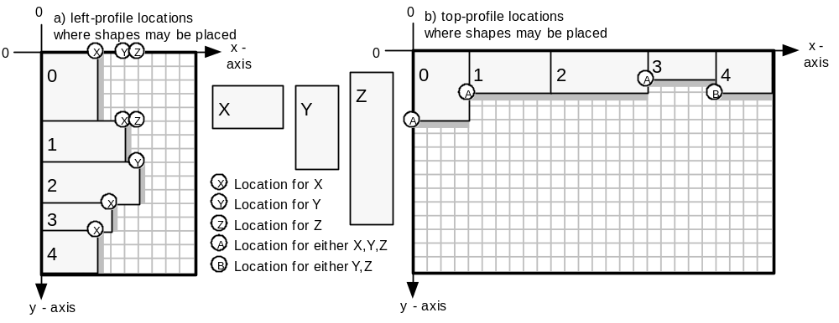
Figure 14. Locations to place shapes X, Y or Z in two layouts, where (a) shows locations derived from a left-profile; and (b) shows locations derived from a top-profile. All locations correspond to the positioning of the top-left vertex of the placed shape.

Figure 14 shows the places found for shapes X,Y and Z by the algorithm above.

Placement Chooser
The chooser picks a single placement position, from all the places found by the placement builder, which satisifies the current placement heuristic, say ‘leftmost’.

The locations stored in left_places and top_places are considered, and a single location which satisfies the current placement heuristic is picked.

If the shape is to be placed leftmost, then all locations in left_places and only the first location in top_places are considered. The location found with smallest x-offset is picked. If there are two or more locations with equally small x-offset, the location with smallest y-offset is picked. (i)

If the shape is to be placed topmost, then all locations in top_places and only the first location in left_places are considered. The location found with smallest y-offset is picked. If there are two or more locations with equally small y-offset, the location with smallest x-offset is picked. (ii)

The reason for considering only the first location in top_places for (i) is that locations in top_places are added to the array (part (3)) in the order in which they have been found in the top-profile. The top-profile is searched from its head, which is the edge leftmost in the top-profile (this is the edge with smallest x-offset).

The reciprocal argument is true for (ii) where only the first element of left_places is considered.

Figure 15 shows how a series of shapes has been placed using a left-top placement regime. Shape 0 is placed leftmost, shape 1 – topmost, shape 2 – leftmost, and so on. Shape 8 is the next shape to be placed. Edge profiles are shown, and edge hotspots have been omitted for clarity.

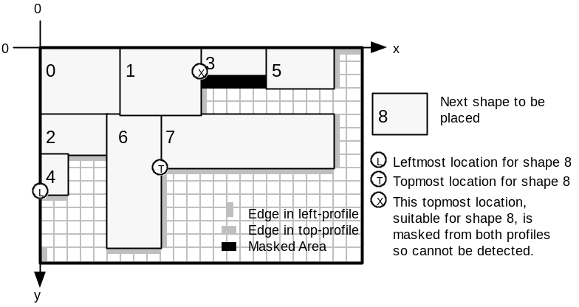
Figure 15. Shapes 0-7 have been placed using a left-top placement regime, beginning with the leftmost heuristic. Shape 8 is the next shape to be placed. Topmost and leftmost locations are labelled. The masked area is unusable as it has a shape to the right and a shape below it, rendering the area ‘invisible’ to both profiles. Loss of location X is an example of the limitations of the dual-representation.

Free-Space Updater
The free-space updater adjusts the free-space representation to take account of a newly placed shape.

Once a place has been chosen for the shape, both left- and top-profiles are updated to account for the revised layout. The algorithm deals with four scenarios:

- Update left-profile using the right-face of new shape - location chosen from left_places
- Update left-profile using the right-face of new shape - location chosen from top_places
- Update top-profile using the bottom-face of new shape - location chosen from left_places
- Update top-profile using the bottom-face of new shape - location chosen from top_places

In cases (a) and (d) the chosen location has its x-offset and y-offset corresponding to either: the x-edge-offset and y-edge-offset of a single edge hotspot (as typified by the ‘X’ shape locations in Figure 14); or the x-edge-offset of one edge hotspot and the y-edge-offset of a different edge hotspot (as typified by the ‘Z’ shape locations in Figure 14).

In cases (b) and (c) the chosen location does not correspond to hotspot locations in the corresponding edge profile. This is because the profile from which we have derived the placement position is not the same as the profile we are updating.

Cases (b) and (d) are now examined as an example where both profiles are updated. Figure 16 (a) shows a current layout and the states of both left- and top-profiles. Consider Figure 16(b.i), where shape 3a has been added to the layout using a topmost heuristic. The placement chooser returns the position marked with a circle.

We shall firstly consider case (b) – updating the left-profile. Notice that a part of the right-face of shape 3a is masked behind shape 1 and so does not affect the top edge in the left-profile. Part of 3a juts out below the bottom-extent of this edge and affects the second edge in the left-profile, whilst also creating a new edge. In Figure 16(b.ii), shape 3b has been added to the original layout using a topmost heuristic. This time the new shape is completely masked behind shape 1 and so no changes need to be made to the left-profile.

The top-profile is easier to update (case (d)) because the placement position coincides with the hotspot of the second edge in the top-profile. Updates (b.i) and (b.ii) are equivalent problems for updating the top-profile, where a single edge in the top-profile is bisected.
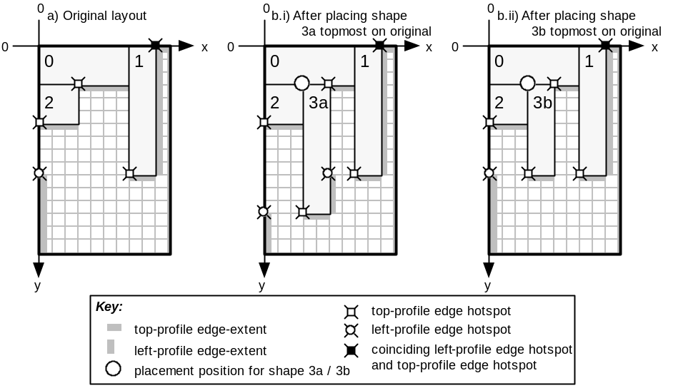
Figure 16. Update scenarios for both left- and top-profiles. (a) A snapshot of the original layout; (b) The layout after adding shape 3a to the original layout; (c) The layout after adding shape 3b to the original layout
These are the types of scenario which the update algorithm has to deal with. Cases (a) through (d) are not explicitly distinguished in the algorithm, but they are all accounted for implicitly. The algorithm was originally written explicitly dealing with the different cases, but the algorithm was found to degenerate into the more elegant solution proposed below.

The algorithm described outlines how the left-profile is updated. The top-profile is updated using the same algorithm, with the necessary changes outlined in Table 1. Below is a list of operations which are carried out by the algorithm. Steps (i-vi) are always executed. Steps (vii-x) are not executed if the new shape is invisible to the left-profile.

- Create a new edge to represent the shape to be added to the layout.
- Find out if any edges in the left-profile connect exactly with the new edge.
- Find the first-edge in the left-profile that might by affected by new edge inclusion.
- Calculate some values.
- Find the start-edge which actually is the first edge to be affected and also find the last-edge-affected by the inclusion of the new edge.
- Check if new shape is invisible to left-profile – if so no update needed – exit algorithm.
- Delete all edges from start-edge to edge before last-edge-affected.
- Delete last-edge-affected if required.
- Adjust new edge hotspot and length if behind an existing edge.
- Integrate new edge into left-profile.

Each of these steps are now detailed.

Create a new edge to represent the shape to be added to the layout.
The new edge is initialised accordingly:
edge-x-offset = x location of right-face of placed shape
edge-y-offset = y location of top-face of placed shape
length = height of placed shape

Find out if any edges in the left-profile connect exactly with the new edge.
Scan the entire edge list to find out if the new edge abuts directly above and / or below any existing edges in the list. The first condition for abuttage is for the edge-x-offset of the existing edge and the new edge to be equal. Secondly, the existing and new edges must run contiguously in the y-axis.
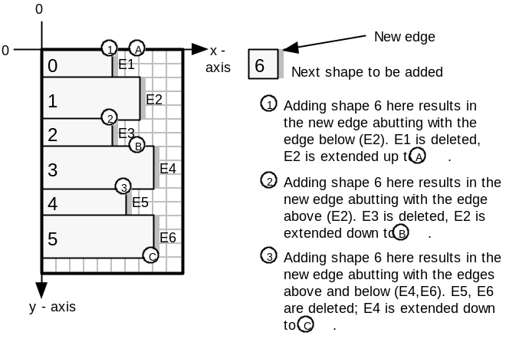
Figure 17. Diagram showing the three types of abutting which can occur when the left-profile is updated.

The following_edge pointer is set to point to any existing edge which abuts below the new edge. The previous-edge pointer is set to point to any existing edge which abuts above the new edge. In the case where there are no abutting edges, these pointers are set to NULL.

Find the first-edge in the left-profile that might by affected by new edge inclusion.
Scan the edge list to find the edge which is horizontally in line with the top face of the new edge. Store a pointer to this edge in both first-edge and start-edge pointers. Figure 18 gives an example.
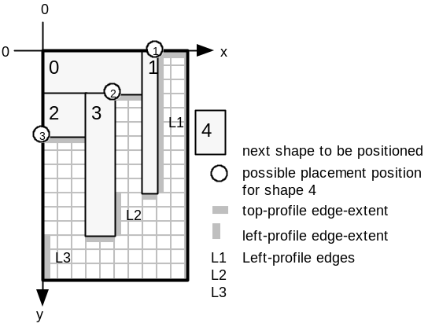
Figure 18. Placing shape 4 at any of the circle locations results in first-edge and start-edge being set to L1.

Calculate some values.
start-offset stores the difference in y-edge-offset between the top of the new shape and the top of the first-edge. This value is 0 for position (1) in Figure 18, 3 for position (2) and 6 for position (3).
accumulated-edge is a distance which is measured starting from the hotspot of first-edge in an increasing y-axis direction. It is used when progressing through the edge profile to find out which edges are affected by the new shape being added and in particular which edge is inline with the bottom-face of the new shape (the last-edge-affected).
The accumulated-edge value is initially set to such a value that results in accumulated-edge equalling the distance between the top-face of the new shape and the bottom-extent of the first-edge (measured in the y-axis direction), after the length of the first-edge has been added to the initial accumulated-edge value. Thus, accumulated-edge is initially set to negative start-offset.

Find the start-edge which actually is the first edge to be affected and also find the last-edge-affected by the inclusion of the new edge.
Setting start-edge to an edge other than first-edge is necessary when the new shape juts out from behind edges in the profile, as shape 3a does in Figure 16(b.i). In the original layout of Figure 16(a) when considering the placement of shape 3a, first-edge is set to the top edge in the left-profile, whilst start-edge is the second edge in the left-profile. The last-edge-affected is also the second edge in the left-profile in Figure 16(a). The algorithm for setting start-edge and last-edge-affected follows:

Initially, SET n to first-edge.
label_1:
Add the length of the nth edge to accumulated-edge and store the result in accumulated-edge. IF new edge has an x-edge-offset less than edge n (ie new edge is behind edge n), set start-edge to point to edge n+1 (the next edge after n in the edge list).
IF accumulated-edge < height of the new shape
GOTO label_1 after setting n to n+1
ELSE
SET the last-edge-affected pointer to edge n.

Check if new shape is invisible to left-profile – if so no update needed and exit the algorithm.
If the hotspot of new edge is behind the hotspot of the last-edge-affected, AND if the bottom edge of the new shape is above the lowest reach of the last-edge-affected, then the new shape is ‘invisible’ to the left profile – so no changes to the left profile are required and we can exit the algorithm. See Figure 16(b.ii) for an example where the new shape is invisible to the left-profile.

Delete all edges from start-edge to edge before last-edge-affected.
Delete all edges beginning with start-edge, up to, but not including, last-edge-affected. This removes any edges bypassed by the new edge. Also set remaining value to accumulated-edge minus new shape height. (remaining is equal to the length of the last-edge-affected that is not overlapped by the new edge. See Figure 16(b.i) where the length of the bottom edge in the left-profile corresponds to this remaining value.)

Delete last-edge-affected if required.
IF the remaining value is zero, delete the last-edge-affected from the edge list, as the last edge is completely overlapped by the new edge.
ELSE move the hotspot of the last-edge-affected such that last-edge-affected abuts below the new edge and reduce the length of last_edge_affected to equal remaining value (See Figure 16(b.i) where the bottom edge in the left-profile is created in this way.)

Adjust new edge hotspot and length if behind an existing edge.
If the new edge hotspot is behind the first edge hotspot then move the new edge hotspot down, such that the new edge is inline with the top-extent of start-edge. Next, reduce the new edge length by the amount the hotspot moved. See Figure 16(b.i) where the new edge in the left-profile, due to shape 3a, is not as long as shape 3a is high. Also, the edge-y-offset of the new edge has been shifted to be in line with the top-extent of the start-edge.

Integrate new edge into left-profile.
(See Figure 17 to see how the abutting process merges existing edges with the new edge.)
IF there is no abutting to do above or below the new edge then add the new edge to the edge list keeping the edge list ordered on increasing y-edge-offset.

OTHERWISE:
If abutting occurs only with following-edge (ie below new edge), set the following-edge hotspot to coincide with the new edge hotspot, then add the length of the new edge to the following- edge length, storing the result.
OTHERWISE:
If abutting occurs only with previous-edge (ie above new edge), increase previous-edge length by new edge length.
OTHERWISE:
If abutting occurs both above and below the new edge, increase previous-edge length by the sum of new edge length and following-edge length. Remove the following-edge from the edge list.

This completes the design and implementation of §2.1.3.5, the Free-Space Updater part of the LDA features. The remaining LDA features are discussed below.

Layout Updater
The layout updater adds the newly placed shape, and its location on the stock-sheet, to the layout. Once a location has been chosen for the new shape, the shape along with its location and a flag indicating whether a new sheet is required is encapsulated inside a layout_piece and is added to the layout_piece array. The layout_piece array is used to recover coordinates for all shapes after the entire layout has been arranged.

Sheet Creator
The sheet creator processes the situation where the current sheet has insufficient space to place the next shape (where the placement builder yields no placement positions).When no placement positions are available for the new shape, a new, empty sheet is used to accommodate this shape and any remaining unplaced shapes. If this new sheet itself becomes full, then another sheet is created. This is a recursive process which generates as many sheets as are required to lay out the permutation described in the current chromosome. All sheets are made to the same (x-size,y-size) dimensions.

Fitness Evaluator
The evaluator returns a fitness value for the current layout corresponding to how efficiently sheets are used. This is calculated by considering the final state of the free-space representation after all shape_genes in the LDA_chromosome have been placed.

The fitness evaluator has to provide a simple metric by which we can evaluate the quality of a layout, and thus the quality of a chromosome. A floating point number in the range 0 to 1 is ideal. There is a two stage process to generate this fitness metric.

Firstly, all sheets required to lay out the permutation, described in the chromosome being evaluated, are analysed. After a sheet becomes full and once the entire layout has been placed, the area used on the current sheet is evaluated and stored in a fitness-report. Once all shapes have been laid out, the fitness-report contains separate area data for each sheet used in the layout.

The area used in each sheet is calculated by dropping a perpendicular line coinciding with the rightmost edge in the sheet’s left-profile, leaving a rectangular free-space area to the right. This free-space is considered ‘good-scrap’ as it may be suitable for reuse. The rectangular area to the left of the perpendicular line is deemed to be the sheet-usage area. Figure 19 illustrates an example of what is included in the sheet-usage area. This may be refined by considering both the free-area to the right of the shapes and the free-area below the shapes on the stock-sheet. In this case there is the possibility for two pieces of good-scrap.
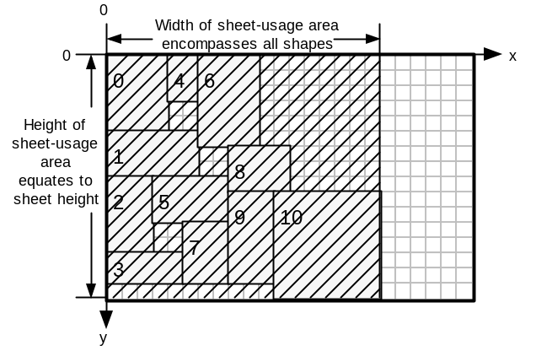

Figure 19. The hatched area represents sheet-usage area for this sheet.

Once all sheet-usage areas are available, an overall-usage function considers:
- the total sheet-usage area for all sheets (total-used-area)
- the total area of all shapes in the layout (min-achievable-area)
- the number of sheets used by the layout (actual-sheet-number)
- the minimum number of sheets that theoretically could contain all shapes.
(min-sheet-number)

The result of the overall-usage function is a floating-point number in the range 0 to 1, where 1 represents perfect fitness. The result is used as the fitness value for the entire layout. The GA uses this fitness value when selecting parent chromosomes for breeding.

LDA_environment class (LDA_e base)

Introduction
The LDA_e class implements a simple level-oriented layout determining algorithm (LDA), as described in §2.1.1. The class is used as a base for the LDA_new class which implements the LDA in §2.1.3.

The environment is responsible for evaluating the layout resulting from considering all genes in a chromosome and for providing a fitness measure for the layout. Environment settings include the size of the stock-sheet to be used. The environment also contains a pointer to a shape group holding all shapes that are to be laid out.

Supplying shapes to the environment
The provide_shapes function is used to supply the environment with a shape group.

Layout Tracking
When evaluating a chromosome, two types of layout data are maintained. The LDA data is used to decide where to place the next shape.The Finalised Layout data is an array of all shapes placed so far, with each shape having a coordinate locating their top-left vertex.

Layout Determining Algorithm Data
In the level-oriented environment, a pointer (max_width_index) refers to the widest shape in the column of shapes currently being placed. Max_width_index references the appropriate shape in the Finalised Layout Data. This data is used by the add_to_layout function to calculate if the next shape is small enough to fit in the current column. If there is insufficient space, a new column is started and the shape is placed there, otherwise the shape is added to the top of the current column.

Finalised Layout Data
The finalised layout consists of an array of layout_piece objects. Each layout_piece object contains:

- a shape_g_l object called piece
- a sheetflag_t object called new_sheet_needed

The piece contains shape size data and a coordinate locating the top-left vertex of the shape. New_sheet_needed is one of:

s_YES: Start using a new stock-sheet from this shape onwards
s_NO: Continue using the current stock-sheet

The first layout_piece has its New_sheet_needed flag set to s_YES. Subsequent layout pieces have their flag set to s_NO. Once a stock-sheet becomes full, only the first shape to be placed on the new sheet has its flag set to s_YES.

The Fitness Function
This function is passed a chromosome for evaluating, which is passed to the fitness_r function. The fitness_r function evaluates the entire chromosome, recursively creating new LDA_e objects to layout across multiple sheets if the current stock-sheet becomes full. The fitness_r function calls the add_to_layout function to process each shape_gene in the chromosome.

Once a stock-sheet becomes full, or once all shapes have been laid out, the sheet_usage function is called to evaluate the dimensions of the area used by the layout on the current stock-sheet. The result of this is stored in a fitness_report object.

A fitness_report object is an array of area_t objects, each containing a width and height measure. After all shapes have been evaluated, the fitness_report object contains a count of the number of sheets used, and the dimensions of the area used on each sheet.

After the fitness_r function has finished placing all shapes, the overall_usage function is called by the fitness function. This function evaluates an overall fitness score for the chromosome, in the range 0 to 1, using the data stored in the fitness_report object. The dimensions and size of the used area on all sheets is taken into consideration. Total areas are compared with the total area of all the shapes that were laid out.

Chromosome Services
As the environment has a pointer to the shape group holding all shapes to be laid out, the environment can initialise chromosomes to hold meaningful data.

Init_chromosome Function
This function initialises the genes of a chromosome with shapes such that the gene-ids progress from 0 to l-1, where l is the length of the chromosome. In other words as the genes are scanned from the gene with index 0, shapes are ordered identically to the shape ordering in the shape group.

Random_chromosome Function
This function stores a random permutation of genes in the chromosome. This results in a random ordering of the shapes. If orientation or heuristic genetic operators are being used, then the respective features of each shape_gene are randomised as well.

Ordered_chromosome Function
This function requires an array of integers which describes the permutation of shapes that is to be stored in the chromosome. Shapes are referred to by their id’s. An array which holds the integers 0 to l-1 in increasing order, where l is the length of the chromosome, would yield identical results to an init_chromosome call.

Get_permutation Function
This function requires a pointer to an array of integers and stores in this array the id’s of all the shapes stored in a chromosome, in order.

Get_permutation_char Function
This function is identical to Get_permutation, except the output is a character array – integers are stored as ASCII characters separated by white space.

LDA_new class (LDA_e base class)

Introduction
This class inherits from the LDA_e class and so shares a large amount of code with this class. The class implements the LDA in §2.1.3 which is the major contribution of this project. The LDA allows shapes to be placed using a variety of fixed and dynamic heuristics across multiple stock-sheets. Fixed heuristics require that one heuristic is used to place all shapes. Dynamic heuristics involve the LDA looking up the heuristic setting for every shape_gene that is processed.

The main functions that LDA_new class overrides are:
- add_to_layout
- clear_layout
- sheet_usage
- overall_usage

Layout Tracking
The Finalised Layout data is stored in the same way as for LDA_e class. The Layout Determining Algorithm Data stores information pertaining to the left and top profiles and also lists of coordinates which hold possible locations for the current shape.

Layout Determining Algorithm Data
The left- and top-profiles for the current sheet are implemented as linked lists of edge_node objects. An edge_node object contains:

- A hotspot location coord object – marks the coordinate of the start of the edge
- A length integer
- An edge_node pointer

Two coord_group objects (left_places and top_places) contain an array of coord objects which are used to hold the collection of locations where the current shape can be placed.

The Fitness Function
The fitness function and the fitness_r function are identical to that of LDA_e class. However, the add_to_layout, sheet_usage and overall_usage functions, which are called by the fitness functions, are overriden.

Add_to_layout Function
This function adds individual shapes to the layout, updating both the profiles and the finalised layout data. Shapes can be placed using one of four heuristics:

- leftmost – The shape is placed as far left as possible on the stock-sheet.
- inner-leftmost – This is the same as leftmost, except locations on the extreme left of the sheet are avoided if possible.
- topmost – The shape is placed as far top as possible on the stock-sheet.
- inner-topmost – This is the same as topmost, except locations on the extreme top of the sheet are avoided if possible.

The inner-leftmost and inner-topmost heuristics bias layouts away from being built-up, initially, along the edges of the stock-sheet, whilst usage of the sheet interior is favoured.

The algorithm follows: (item is the shape_gene to be processed)

- process_current_rule(item);
Sets the current_rule to be the heuristic setting in the item if the shapes are to be placed dynamically.

- status left_build_status=build_left_profile_places(item);
status top_build_status=build_top_profile_places(item);
Examines both profiles for all locations where the item can be placed, storing the results in left_places and top_places coordinate arrays. The status returned is false if no locations have been found in the respective profile.

- if (left_build_status==FAILURE && top_build_status==FAILURE)
return FAILURE;
Return a failure if there are no locations where the item will fit on the sheet

- coord chosen_coord;
switch (current_rule)
{
case LEFTMOST:
chosen_coord=choose_leftmost_place(left_build_status, top_build_status);
break;
case ILEFTMOST:
chosen_coord=choose_ileftmost_place(left_build_status, top_build_status);
break;
case TOPMOST:
chosen_coord=choose_topmost_place(top_build_status, left_build_status);
break;
case ITOPMOST:
chosen_coord=choose_itopmost_place(top_build_status, left_build_status);
break;
default:
break;
}
shape_g_l chosen_gene(item, chosen_coord);
The current_rule stores the heuristic which decides which of the locations to choose to place the item. The chosen_gene variable stores both the shape dimensions and the shape’s location on the stock-sheet.

- layout[next_index].piece=chosen_gene;
next_index++;
The layout array stores the shape and its location on the stock-sheet.

- add_shape_at_place_6(chosen_gene, MODIFY_LEFT_PROFILE);
add_shape_at_place_6(chosen_gene, MODIFY_TOP_PROFILE);
Calling this function updates both left- and top-profiles to take into account the new shape on the stock-sheet.

Sheet_usage Function
This function returns an area_t object, which consists of width and height integer data. The width of the layout is determined by finding the right-most edge in the left-profile. The height of the layout is determined by finding the bottom-most edge in the top-profile.

Overall_usage Function
This function calculates the fitness of an entire multi-sheet layout:

sheets_used = number of sheets required for the layout
last_sheet_usage = sheet_usage for the stock-sheet holding the last placed shape
total_usage = sum of sheet_usage areas for all stock-sheets used by the layout
total_area = sum of individual shape areas
sheet_area = sheet_width * sheet_height

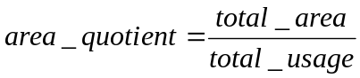

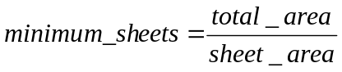

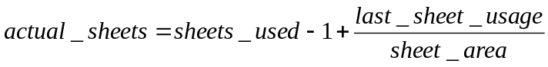

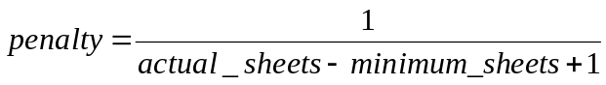

The main influence on overall fitness is the area_quotient. If the packing of the layout is very efficient (ie little wasted space), then this value will be close to one. The penalty function penalises the use of more sheets than is the absolute theoretical minimum. This is necessary as otherwise a layout which uses one stock-sheet per shape would have a fitness of one. This is because the sheet_usage area consists of the bounding box containing all the shapes placed on a single stock-sheet.

Population-Related Design
This section covers the population representation and the selection operators that pick chromosomes from the population.

Population Class
The population class is a collection class for chromosomes. When a population object is created, it is supplied with two parameters:

- an example of the type of chromosome required in the population
- the size of the population

The create_array function available in the chromosome class is used by the population class to create an array of chromosomes. The following services are provided by the population class:

- get_candidate – returns a reference to an integer-indexed chromosome in the population. Indexes range from 0 to p-1, where p is the population size
- new_candidate – uses the chromosome clone function to return a newly allocated chromosome that is compatible with the other chromosomes in the population
- replace_candidate – this is provided with an index location which locates a chromosome in the population to be overwritten – a chromosome pointer is also provided, which points to the chromosome that is to be copied into the population
- randomize population – calls the random_chromosome function for each chromosome in the population
- standardize population – calls the init_chromosome function for each chromosome in the population

Selector Classes
Selector classes are used to pick chromosomes from a population for breeding and for removal.

Selector Base Class
This class forms the base for all selection classes. When a selector is created, it must be supplied with a pointer to a population to select from. All classes derived from the selector class have to provide the following functions:

- select_index – this returns an integer indexing a single chromosome in the population – the result of the selection procedure.
- select_candidate – this returns a pointer to the selected chromosome.
- clone – this returns a pointer to new selector-type object, with duplicate data as that of the selector object used to call this function.

The following function is provided by the selector class and is not overridden by derived selector classes:

- make_child – this returns a pointer to a new chromosome, which is of a type compatible with the population being selected from.

Rank Selection – rank_s class
All candidates in the population have their fitness evaluated, and the population is ordered according to decreasing fitness. The first member of the ordered population (the fittest candidate) has n-times the probability of being selected than the least fit candidate, where n is the number of candidates in the population. The second-most fit candidate has (n-1)-times the probability of being selected than the least fit candidate, and so on for the rest of the population. The probability of the least fit candidate being selected is 1 / (1 + 2 + ... + (n-1) + n) = 1 / (n * (1+n) / 2).

Tournament Selection – tournament_s class
A tournament may be held amongst m randomly picked candidates in the population. The tournament winner is the fittest candidate amongst those picked. m defaults to two, but may be set to any integer values greater than or equal to two when the tournament_s object is created.

Best Selection – best_s class
This class always selects the best chromosome in the population.

Worst Selection – worst_s class
This class always selects the worst chromosome in the population.

Worst By Rank (Inverted Rank) Selection– worst_rank_s class
This class uses inherits from rank_s class, but inverts the selection function so that the worst chromosome is most likely to be picked.

System-Related Design
This section discusses the system components which drive the evolution process. In §4.1 methods for selecting which genetic operators to use are discussed. In §4.2, generational models are described. These provide the control to evolve a population of chromosomes one generation. In §4.3, the evolution driver is described. This component pulls together the whole system.

Operator Rate Adaptors
Operator rate adaptors determine which genetic operator to apply next to the population.

Adaptor Base Class
The base class has the following data members:

- A 100 element array of crossover-type pointers
- A 100 element array of mutation-type pointers
- A pointer to a selection method

When creating an adaptor, a selection operator must first be created and passed to the adaptor. The selection operator provides a link to the population to evolve and decides which chromosomes to breed. The crossover and mutation operators that have been selected for use are then supplied to the adaptor, using:

- add_crossor – an example of the mutation operator required is passed using this function
- add_mutator – an example of the crossover operator required is passed using this function

These two functions clone the operator examples which they are given and store these new operators in the crossover and mutation operator arrays of the operator rate adaptor.

The apply_operator function has the job of applying a genetic operator to the population and obtaining a resulting child. The apply_operator function is a pure virtual function, and so must be overridden in a derivative class. The apply_operator function is used to :

- pick a single operator from one of the operator arrays
- select one parent in the case of mutation, or two parents in the case of crossover
- create a child chromosome which will store the result of the genetic operator
- pass the parent(s) and child to the chosen genetic operator
- return a pointer to the child

Note that the operator adaptor assigns memory for the children which are produced. The adaptor is not responsible for putting the child into the population; this is the job of the Generational Model (4.2).

COst Based Operator Rate Adaptor – COBRA_a class
All classes derived from the adaptor class have to override the apply_operator function. The COBRA rate adaptor does the following:

- For the first i calls to the apply_operator function, the next genetic operators to use is chosen at random. A score is kept of how good each genetic operator is at generating children which are better than their parents.
- Once i calls to the apply_operator function have been made, the overall scores for all the genetic operators are used to generate a list which orders operators on decreasing score.
- For all subsequent calls to the apply_operator function, instead of operators being chosen at random, they are chosen probabilistically depending on their place in the score list. A rank-based selection is used which is identical to that used in the rank chromosome selector, rank_s class. The chance of selecting the least fit operator is
1 / (1 + 2 + ... + (n-1) + n) = 1 / (n * (1+n) / 2), where n is the number of operators
and the chance of selecting the fittest operator is n times this value.

The COBRA rate adaptor has three parameters:

- iteration_point – determines the number of calls that are to be made to the apply_operator function before the genetic operators are assessed for overall score. The function, set_iteration_point sets this value.
- mutation_points – the number of points to be added to a mutation operator’s score when a child is generated which is fitter than the parent. By default this is set to the value, 2.
- crossover_points – the number of points to be added to a crossover operator’s score when a child is generated which is fitter than one parent. The score is doubled if the child is fitter than both parents. By default this is set to value, 1.

The mutation_points value is twice the crossover_points value so that crossover operators aren’t unfairly advantaged. When a crossover operator generates a child, the child is compared in fitness to both parents. A mutation operator can have its child compared only to the one parent.

Random Rate Adaptor – random_a class
This operator adaptor makes a random choice made by considering all crossover and all mutation operators available. The chosen operator is then used to generate a child, having been supplied with selected parent(s).

Fixed Rate Adaptor – fixed_a class
This operator adaptor chooses whether to apply a crossover operator or a mutation operator probabilistically. The probability of using a crossover operator is set using the set_rate function. After deciding which type of operator to apply, a random choice is made from all the operators of that type. The chosen operator is then used to generate a child, having been supplied with selected parent(s).

Adaptive Mutation – adaptive_mutation_a class
This operator adaptor uses the Hamming distance between two chromosomes to determine whether to apply a crossover or a mutation operator. The probability of using a crossover operator is determine by:
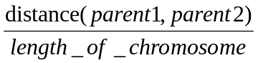

The distance operator compares each gene in parent1 against the respective gene in parent2. If the gene-ids for a single comparison do not match, the distance measure is increased by one. Comparisons are made for every gene in the chromosome.

After deciding which type of operator to apply, a random choice is made from all the operators of that type. The chosen operator is then used to generate a child, having been supplied with selected parent(s).

Generational Models
The generational model has the task of controlling the creation of a new generation of chromosomes from a population. An operator rate adaptor is required to generate child chromosomes. A strategy for integrating the child (or children) back into the population is also required.

Generational_Model Base Class
The base class has the following data members:
- a pointer to the population to be evolved
- a pointer to an operator rate adaptor
- a pointer to a selection operator
- a finished boolean – used in some stochastic models

The base class requires the evolve_once function to be overriden. This function uses the member data objects to complete one generation of evolution.

Steady-State Model – steady_state class
The steady-state model uses the operator adaptor to create one child chromosome from the population. In the steady-state model the population size stays constant. To deal with this, a selection operator is used to pick a chromosome for removal. A usual selector operator to use is the worst_s selector which picks the least-fit chromosome. The replace_candidate function, in the population class, is used to replace the chosen chromosome with the child chromosome. This involves copying the gene information from the child to the picked chromosome in the population. After copying the child into the population, the child chromosome is no longer required and is deleted.

Stochastic Model – stochastic class
The stochastic model is used for Hill Climbing (HC), Steepest Ascent Hill Climbing (SAHC) and Simulated Annealing (SA). The model requires a population which has a size of one. Each of HC, SAHC and SA has a special mutation operator which is used in conjunction with the stochastic model.

When a stochastic object is created, it requires pointers to a special mutation operator, a population and an operator rate adaptor. The special mutation operator determines whether HC, SAHC or SA is to be performed.

The stochastic model keeps a record of the fittest chromosome formed since the model was created. Also, after each call to evolve_once, the model checks to see if the special mutation operator has terminated. If this is so, the finished boolean (defined in the base class) is set to true. This is required for SA as the process finishes once the minimum temperature has been reached.

The special mutators require an operator rate adaptor in order to apply a normal mutation operator to the single chromosome in the population. The literature review contains additional information concerning HC, SAHC and SA.

Special Mutator – Random
This mutation operator simply randomizes the parent chromosome.

Stochastic – Hill Climbing
Hill Climbing has one parameter – the restart threshold. The operator adaptor is used to apply a mutation operator (say swap mutation) to the current chromosome. If the child chromosome is fitter than the original, then the original is replaced by the new chromosome. Otherwise, the original solution is kept and the operator adaptor is applied again. If the operator adaptor generates the threshold number of children without improving on the current solution, then the hill climbing algorithm is restarted. This involves randomizing the current solution.

Stochastic – Steepest Ascent Hill Climbing
The sample rate parameter determines how many samples to take before hill climbing. In standard hill climbing a single sample is taken. In SAHC the best chromosome out of the sample obtained is selected.

Stochastic – Simulated Annealing
This mutator has the following parameters:
- start_temp – Temperature with which to start the annealing process
- end_temp – Temperature which signals the end of the annealing process
- cooling_ratio – Rate at which temperature is decreased – must be less than 1.0 and greater than 0.0.

The reset_mutator function is called before annealing begins, in order to reset the current temperature to start_temp.

Each time the mutate function is called, one step in the simulated annealing process is made and the cooling schedule is updated (start_temp is multiplied by the cooling_ratio). If start_temp becomes less than or equal to end_temp, the finished flag is set to true.

Evolution Driver

Introduction
The evolution driver uses the settings in the GA Settings Dialog Box (see the User Manual) to prepare and run the GA experiment. §4.3.2 summarises the algorithm.

Evolution Driver Algorithm
Get the frequency at which reports are to be made, from GA Settings Dialog Box

IF generational model is one of : HC, SAHC, SA or Random
Set population size to one
ELSE
Get population size
ENDIF

Create a population of the appropriate size

IF generational model is Steady-State
Create a breed-selector of type according to GA Settings Dialog Box setting
ELSE
Create a breed-selector of select best type
ENDIF

Create a removal-selector based on GA Settings Dialog Box settings

Create a best-selector and a worst-selector.

Create an operator rate adaptor according to GA Settings Dialog Box settings
Pass the breed-selector to the operator rate adaptor

IF generational model is Steady State
FOR all crossover operators that have been selected in the GA Settings Dialog Box
add an example of each crossover operator to the operator rate adaptor
ENDFOR
ENDIF

FOR all mutation operators that have been selected in the GA Settings Dialog Box
add an example of each mutation operator to the operator rate adaptor
ENDFOR

Randomize the population:
- Randomize the permutation of genes in all chromosomes.
- If crossover/mutation operators that manipulate orientation flags have been selected for use, then randomize orientation flags in all genes for all chromosomes.
- If crossover/mutation operators that manipulate heuristic settings have been selected for use, then randomize heuristic settings in all genes for all chromosomes.

Create a Generational Model according to GA Settings Dialog Box settings

Create a Cataclysmic Mutator:
- If crossover/mutation operators that manipulate orientation flags have been selected for use, then set the randomizer to randomize_feature_1. Set mutate_features to true.
- If crossover/mutation operators that manipulate heuristic settings have been selected for use, then set the randomizer to randomize_feature_2. Set mutate_features to true.
- If both (1) and (2) are required then set the randomizer to randomize_all_features
- If none of (1) to (3) are applicable, set mutate_features to false.

INITIALISE iteration_count to zero, and duplicate_count to zero

DO
Set the finished parameter of the generational model to false.
Call the evolve_once function of the generational model.
If the finished parameter is now true
BREAK out of the DO loop
IF a report is to made on this iteration
Get the best and worst chromosomes in the population and evaluate fitness
Set duplicate_count to no. of chromosomes similar in fitness to best
Output report
IF cataclysmic mutation is active (set in GA Settings Dialog Box)
IF no. of duplicates exceeded threshold (in GA Settings Dialog Box)
Cataclysmically mutate the population
IF best fitness is within 0.01 of max fitness (1)
BREAK out of the DO loop
WHILE (Number of generations not reached maximum)

User Manual for StockGA Application

Introduction
This section explains the user operation of the StockGA application. First, the input file format is described. The input file holds shape information for all layouts, or tests, which are to be loaded in to the application at start-up. In the following section, an application snapshot and its visible features are presented. Next, the application menu items are covered.

Application Overview
StockGA processes layouts which are contained in the ‘shapes.txt’ input file. Each layout, or test, is an independent entity. When a test is initially displayed on the screen, the shapes defined in the test are laid out in the order found in the input file. If the layout requires more than one stock-sheet, the user can navigate through all sheets using the menu commands. Likewise, all layouts in the input file can be navigated using the menu commands.

By using the GA Settings dialog box, the user sets all parameters for running a GA experiment. To run the experiment, the ‘Run GA’ menu command is used. Whilst the GA experiment is running, status information including: number of generations processed and best and worst fitnesses in the population, are displayed in the output window. Once the experiment has finished, the evolved layout is displayed in the application window.

The layout currently on display in the application window can be exported to a text file (called layout.txt). All shape and location data, the total area used on each sheet and an overall fitness score are stored in this file.

Test Data File Format
Test data must be stored in a text file called ‘shapes.txt’. There is no limit to the number of tests that this file may contain. Each test is separated by white space, and the format to be used for each test is as follows:

<test-id> <shape-list> <test-description> <!> <regime> <sheet-width> <sheet-height>

All fields <> are delimited by white space. Table 2 describes the contents of each field.

<test-id> | A single string delimited by white-space which may contain up to 9 characters.
<shape list> | This field contains a list of shape specifications. Each specification contains an integer width, an integer height and a trailing comma (,). All specifications are separated by white-space. The last specification has a trailing colon (:). eg 2 2, 3 3, 4 4:
<test-description> | This field may contain up to 999 characters, including white-space. The exclamation (!) character must not be used in this field.
<!> | This field consists of a single ‘!’ character and must have white-space either side of it.
<regime> | This field must contain exactly one of the following (capitalised) labels:  { LEFTMOST ILEFTMOST TOPMOST ITOPMOST DYNAMIC }  This field sets the regime (or heuristic) used by the layout determining algorithm for placing shapes.
<sheet-width> | A positive integer which sets the width of a single stock-sheet.
<sheet-height> | A positive integer which sets the height of a single stock-sheet.
Table 2. Fields making up a single test in the input test file, ‘shapes.txt’. All shape and sheet sizes must be integer values.

An example consisting of three test entries:

1.1L) 20 10, 20 15: Force abutting in y-axis with previous ! LEFTMOST 30 30
1.2L) 20 10, 15 10, 20 10, 5 10: Force abutting in y-axis with previous and following ! LEFTMOST 30 30
1.3L) 20 10, 15 10, 20 10, 4 5, 5 5: Force abutting in y-axis with following ! LEFTMOST 30 30

Application Snapshots
The main application window is illustrated in Figure 20.

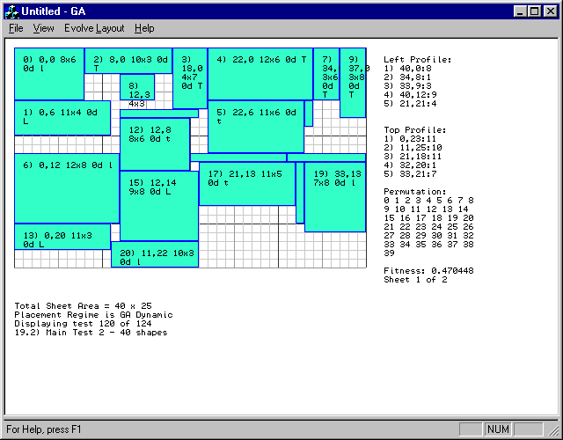
Figure 20. The StockGA Main Application Window.

The menu bar contains commands for manipulating the current layout, for running GA experiments, for navigating through sheets used in this layout, and for navigating other tests present in the test file.

The stock-cutting outline is placed on top of a grid which represents a single stock-sheet. The grid lines are drawn at unit intervals. Each placed shape has an annotation (which may not be visible if the shape is too small) which contains the following data: shape-id, coordinate of top-left vertex, dimensions of the shape, whether the shape is rotated 0 or 90 degrees, and a single character indicating the heuristic used to place the shape. For example, the top-left shape in the layout of Figure 20 has the following annotation:

0) 0,0 8x6 0d l

In this example, the shape-id is zero, the coordinate of the top-left vertex is (0,0), the size of the shape is (8x6), the shape has 0 degrees rotation and the heuristic ‘l’ has been used to place the shape. Shape-ids are assigned to shapes in the order in which they are found in the test specification.

Heuristic Label | Full-name of Heuristic
L | LEFTMOST
l | ILEFTMOST (Inner leftmost)
T | TOPMOST
t | ITOPMOST (Inner Topmost
Table 3. Heuristic labels and their corresponding full names.
Edges specifications for edges in the left and top edge profiles are displayed in the order found in their respective list. An edge specification consists of an (x,y) coordinate (called the hotspot), followed by the length of the edge. For left profile edges, the hotspot is the top-most extent of the edge. For top profile edges, the hotspot is the left-most extent of the edge.

Other information displayed includes: the permutation of shapes that has been laid out; the overall fitness of the layout; the number of sheets the layout uses and the current sheet being displayed; the total sheet area; the placement regime used to place shapes; and test-id and test description information.

The output window (see Figure 21) displays status data pertaining to the latest GA experiment. This display is updated whilst the GA experiment is running. The fields from left-to-right are: number of generations evolved, fitness of best chromosome, fitness of worst chromosome and the number of ‘duplicate’ chromosomes present in the population. A ‘duplicate’ chromosome has a ‘similar’ fitness to the fittest chromosome. The ‘CM’ annotation denotes that the number of duplicates has exceeded a ‘threshold’ and that the population has been cataclysmically mutated. The definitions of ‘similar’ and ‘threshold’ are set in the GA Settings Dialog.

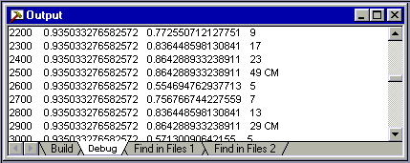
Figure 21. The StockGA Output Window.

Application Menu Commands
Menu commands having a keyboard-shortcut, have the shortcut in brackets after the command name.

File Menu

Export Layout (Alt+L)
The layout of all sheets for the test currently displayed in the application window is output to the ‘layout.txt’ text file. Figure 22 provides an example of the exported data.

Test performed: 09/07/98 15:09:50
Test 100 of 124
Test Description: 13.6T) Left placed shape masking edges 2,3,4 in top profile
Sheet Size = 30x30
Number of Sheets Used = 1

Fitness Report:
Sheet 0: Area Used = 25x30

Overall Fitness Of Layout: 0.475127

Formatted Output:
Col 1: S=New Sheet, -=No New Sheet
Col 2: Shape ID
Col 3: Rotation=0 or 90 Degrees
Col 4: Shape Size: (X-size x Y-size)
Col 5: Location: (X , Y)

S ID=0 R=0D 10x5 (0,0)
- ID=1 R=0D 5x5 (10,0)
- ID=2 R=0D 11x6 (0,5)
- ID=3 R=0D 6x3 (15,0)
- ID=4 R=0D 11x19 (0,11)
- ID=5 R=0D 4x4 (21,0)
- ID=6 R=0D 14x6 (11,5)
Figure 22. Typical layout information output to the ‘layout.txt’ file.

Print (Ctrl+P)
Outputs the contents of the application window to a connected printer. Only the currently displayed stock-sheet is printed. To print multi-sheet layouts, navigate through each sheet and print them individually.

Print Setup
Allows printer-specific parameters to be set.

Exit
Quits the StockGA Application.

View Menu

Refresh (Alt+R)
Reloads the ‘shapes.txt’ layout information file. This command is to be used after a modification has been made to the layout file whilst the StockGA application is running.

Normalise Chromosome (Alt+N)
Lays out the shapes for the current test in the order specified in the test file. This corresponds to a shape-id permutation of 0, 1, 2..., n-1, where n is the number of shapes in the test.

Shuffle Chromosome (Alt+W)
Lays out the shapes for the current test in a random order.

Order Chromosome (Alt+O)
Lays out the shapes for the current test in an order specified by the user. The order is specified as a list of non-negative integers in the range 0 to n-1, where n is the number of shapes in the test. The integer list is verified for being a valid permutation.

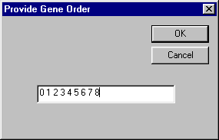
Figure 23. Dialog Box invoked when the Order
Chromosome menu command is invoked.

Next Test (Alt+X)
Updates the application window with the layout and test information corresponding to the test following the test currently displayed.

Previous Test (Alt+Z)
Updates the application window with the layout and test information corresponding to the test preceding the test currently displayed.

Next 10th Test (Alt +D)
Changes the current test to the test which is the tenth test following the current test.

Previous 10th Test (Alt+A)
Changes the current test to the test which is the tenth test preceding the current test.

Goto Test... (Alt+G)
Changes the current test to a test specified by the user. Tests are identified by their position in the test file.

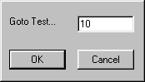
Figure 24. Dialog Box invoked when the ‘Goto Test’ menu command is invoked.

View Next Sheet (Alt+0)
Updates the display to show the next sheet for the current layout.

View Previous Sheet (Alt+9)
Updates the display to show the next sheet for the current layout.

Set Regime For This Test (Alt+T)
Allows the user to change the regime used for laying out shapes in the current test. The change is retained until the test file is reloaded using the ‘Refresh’ menu command.

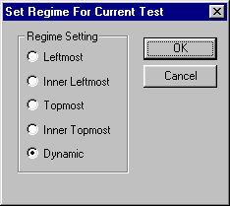
Figure 25. Dialog Box invoked when the ‘Set Regime’ menu command is invoked.

Evolve Layout Menu

GA Settings (Alt+S)
This command invokes the dialog in Figure 26.

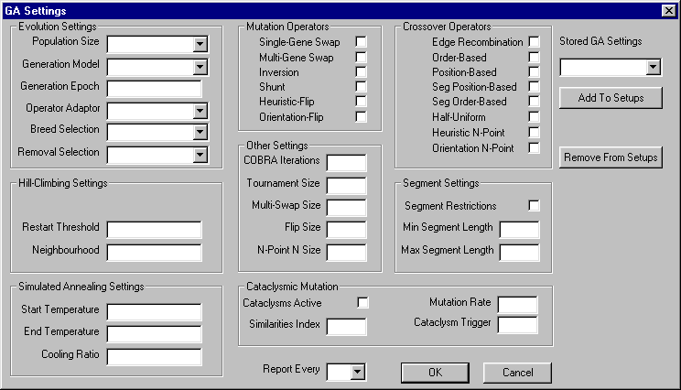
Figure 26. GA Settings Dialog Box used for configuring all GA experiment parameters.

Parameter | Possible Values
Population Size | 50 | 100 | 150 | 200
Generational Model | Steady-State GA | Hill Climbing | Steepest Ascent Hill Climbing | Simulated Annealing
Generation Epoch | Positive Integer Value – Number of generations to evolve
Operator Adaptor | Adaptive Mutation | COBRA | Fixed Rate | Random
Breed Selection | Rank | Tournament
Removal Selection | Least-Fit | Inverted Rank
Table 4. Summary of values that evolution settings can have.

Settings Group | Parameter Name | Purpose
Hill Climbing Settings | Restart Threshold | If fitness is not improved after this no. of hill-climbing iterations, then the current solution is randomised.
Hill Climbing Settings | Neighbourhood | Number of samples to taken at each hill-climbing iteration in Steepest Ascent Hill Climbing
Simulated Annealing Settings | Start Temperature | Initial value that current temperature is set to
Simulated Annealing Settings | End Temperature | Value for current temperature that terminates SA
Simulated Annealing Settings | Cooling Ratio | Current temperature is multiplied by this factor at each iteration of SA
Segment Settings | Segment Restrictions | When selected, restricts segment crossover operators to segment lengths between Min and Max values.
Segment Settings | Min Segment Length | Minimum gene-length that segment crossover operators act upon
Segment Settings | Max Segment Length | Maximum gene-length that segment crossover operators act upon
Cataclysmic Mutation | Cataclysms Active | When selected, enables cataclysmic mutation
Cataclysmic Mutation | Similarities Index | Ranged between 0 and 1 – determines how close a chromosome has to be in fitness to the best chromosome before being counted as a duplicate
Cataclysmic Mutation | Cataclysms Trigger | Number of duplicates in the population that triggers cataclysmic mutation
Cataclysmic Mutation | Mutation Rate | Ranged between 0 and 1 – determines percentage change made to all chromosomes except the best one, when cataclysmic mutation takes place
Other Settings | COBRA Iterations | Number of times that a COBRA rate adaptor may apply genetic operators at random to determine their relative usefulness
Other Settings | Tournament Size | Number of chromosomes to be considered when tournament selection is used
Other Settings | Multi-Swap Size | Number of pairs of genes to swap in multi-swap mutation
Other Settings | Flip Size | Number of genes to mutate every time orientation mutation or heuristic mutation is used
Other Settings | N-Point N Size | Number of crossover points to use in orientation n-point crossover and heuristic n-point crossover
Table 5. Summary of GA Settings Dialog parameters

Table 4 and Table 5 summarise the parameters that affect how the GA experiment runs. In addition to these, there are check-boxes that allow the user to select which mutation and crossover operators to use. The ‘Report Every’ parameter determines how often the GA reports its current status. The type of experiment is determined by the Generational Model parameter. The Steady-State value for this parameter enables a GA to run. All other settings cause a stochastic experiment to run, such as Hill Climbing.

The ‘Stored GA Settings’ parameter provides a method for saving all current GA Settings in a file for future use. To enable this function, a name is entered into the ‘Stored GA Settings’ drop-down list-box and the ‘Add to Setups’ button is clicked. Previously stored setups appear in the drop-down box. The ‘Remove From Setups’ button allows setups to be erased. Setups are saved when the GA Settings Dialog is closed using the OK button. If the CANCEL button is clicked then any newly defined setups are not stored to disk. Setups are stored in a binary file called ‘setups.bin’.

Certain sets of parameters are disabled depending on which Generational Model is selected. For example, only the Steady-State Generational Model uses crossover operators. Figure 27, Figure 28 and Figure 29 show how the GA Settings dialog appears for different Generational Model settings. Ghosted parameter fields are not active.

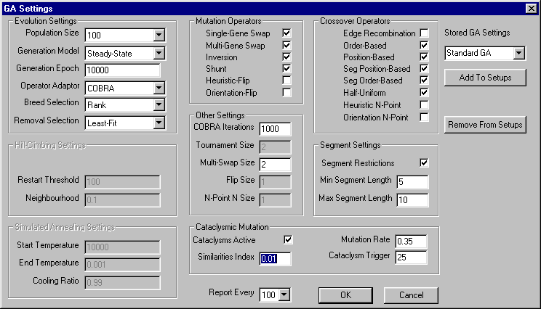
Figure 27. GA Settings Dialog status when Steady-State is selected
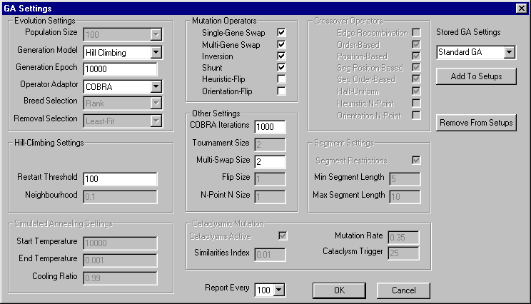
Figure 28. GA Settings Dialog status when Hill Climbing is selected
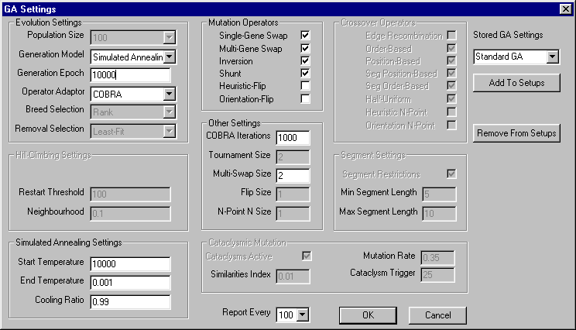
Figure 29. GA Settings Dialog status when Simulated Annealing is selected

Run GA (Alt+E)
This command runs the GA experiment using the parameters set in the GA Settings Dialog. Current status, throughout the experiment, is reported in the output window. After the experiment has concluded, the fittest chromosome has its layout displayed in the application window. Figure 21 illustrates the output window. Layout data can be written to disk using the ‘Export Layout’ command.

Batch Process (Alt+B)
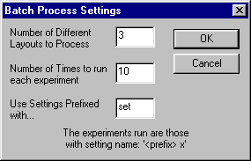

Detailed Output

Help Menu

About GA...
Displays a dialog box that summarises the use of the StockGA application.

Important Algorithms
Algorithms which were found to be the most challenging are included in this section. The idea for the permutation generator was proposed to me by my project supervisor, whilst the rest are of my own design. By far the most challenging algorithm was the LDA, in §2.1.

Permutation Generator
Parameters: INTEGER max_number, INTEGER permutation_length, INTEGER ARRAY permut
Returns: Nothing – stores permutation in the permut array

max_number – The number of different values that may occur in the permutation. eg chromosome length
permutation_length – The number of random, unique values that are required
permut – Array which stores the resulting random numbers

This function generates unique random integers in the range: 0 to max_number-1. If permutation_length=max_number, then the permut array contains a true permutation. However, by setting permutation_length<max_number, a smaller quantity of random numbers, in the specified range, can be obtained. This is good for picking, for example, two unique genes in a chromosome.

DEFINE an ARRAY OF max_number INTEGERS (initial array)
STORE the numbers 0 to max_number-1 sequentially in the initial array

INTEGER random_index
FOR i ranged from 0 to permutation_length - 1
SET random_index = random() MOD (max_number - i)
SET permut[i] = initial[random_index]
SET initial[random_index] = initial [length - 1 - i]

ENDFOR

Crossover Operators
All crossover operators have a cross function which accepts three pointers:
- p1 – pointer to parent1 chromosome
- p2 – pointer to parent2 chromosome
- c – pointer to a chromosome that is to be used to store the child

Order-based crossover

Introduction
Section 1: Generates an index_mask and an id_mask
Both masks are n-bit representations of type BITSTREAM, where n is the length of a chromosome. The BITSTREAM class uses an attached character array to store data and allows bitwise reading and writing operations on the mask.

The index_mask has high bits whether a gene is selected from parent2.
The bit-positions indexed by the gene_ids of these genes are set high in the id_mask.

The index_mask is generated by:
- setting all bits in the mask randomly
- If bit-i in the index_mask is high, then gene i in parent2 is selected.

The id_mask is generated by :
- scanning the index_mask for all high bits
- For high bit-i, look-up the gene_id of gene i in parent2 – set bit-(gene_id) in id_mask high

Section 2: Generate child chromosome
The child is provisionally a copy of parent1, except all genes with gene_ids flagged high in the id_mask are reordered according to their order in parent2.

Algorithm
SECTION 1
{
SET length = length of parent1 chromosome
SET mask_word_length = ceiling(length / 16) // Number of 2-byte words required
SET mask_char_length = mask_word_length*2 // Number of chars required

DEFINE index_mask_array ARRAY OF mask_char_length UNSIGNED CHAR
DEFINE index_mask BITSTREAM
ATTACH index_mask_array to index_mask – call index_mask.attach_char_array function

// Generate the index mask bit pattern
FOR i ranged from 0 to mask_word_length-1
APPEND random 16-bit number to index_mask – call index_mask.append_word
ENDFOR

CALL index_mask.reset_read_write()

DEFINE id_mask_array ARRAY of mask_char_length UNSIGNED CHAR
DEFINE id_mask BITSTREAM
ATTACH id_mask_array to id_mask – call id_mask.attach_char_array function
CALL id_mask.wipe_clean()

// Generate the id mask by looking up the gene_ids of all genes flagged in the index mask bit pattern
FOR i ranged from 0 to length-1
IF (Bit-i of index_mask == 1)
SET t = gene_id of gene i of parent2
SET the Bit-t of id_mask to 1
ENDIF
ENDFOR

CALL id_mask.reset_read_write()
}

SECTION 2
{
SET index = -1
FOR i ranged from 0 to length-1
SET t = gene_id of gene i of parent1
IF (Bit-t of id_mask == 0) // Gene_id not selected in parent 2
Copy gene i from parent1 to gene i of child
ELSE // Gene_id selected in parent 2
// Find the next gene in parent2 to be copied to the child
DO
SET result = bit value of next bit retrieved from index_mask
WHILE (result = false)
Copy gene index from parent2 to gene i of child
ENDIF
ENDFOR
}

Invalidate the fitness of the child

Position-based Crossover

Introduction
Section 1: Generates an index_mask and an id_mask
Both masks are generated as Section 1 of the order-based crossover algorithm.

Section 2: Generate child chromosome
All genes flagged by a high-bit in the index_mask are copied from parent2 to the corresponding genes in the child. Remaining genes are copied in the sequence found in parent1 to the child.

Algorithm

SECTION 1{ Same as Section 1 of order-based crossover algorithm }

SECTION 2
{
// copy all chosen genes from parent2 to child
// Examines all bits in the index_mask
FOR i ranged from 0 to length-1
IF (Bit-i of index_mask == 1)
Copy gene i from parent2 to gene i of child
ENDIF
ENDFOR

// Genes not flagged in the index_mask are copied from parent1 to the next available
// gene location in the child.
SET ci = -1
SET pi = -1
DO
// find next gene to take from parent1 – store index of next gene in pi
DO
INCREMENT pi
SET t = gene_id of gene pi in parent1
WHILE (pi<length AND Bit-t of id_mask==1)

IF (pi==length) // all parent1 genes searched
BREAK out of LOOP

// find next gene in child which can store the parent1 gene – store index of next gene in ci
DO
INCREMENT ci
SET t = gene_id of gene ci in parent2
WHILE (pi<length AND Bit-t of id_mask==1)

Copy gene pi in parent1 to gene ci in child

WHILE (ci<length-1)

Invalidate the fitness of the child
}

Edge-recombination Crossover

Introduction
Two classes are required in addition to the crossover algorithm:

allele_map class: Stores up to 4 edge references
Functions:
- add_edge : adds a specified edge to the allele_map
- remove_edge : removes a specified edge from the allele_map
- get_edge_count : returns the number of edges stored (maximum of 4)
- clear : sets number of edge stored to zero

edge_map class: Stores an array of allele_maps. Number of elements is equal to number
of genes in a chromosome.
Functions:
- add_to_edge_map : provided with an array of integers forming a valid
permutation, this adds all edges to the edge_map
- remove_allele_from_map : provided with a single integer, i – all edges i in all
allele_maps are deleted.
- choose_allele_with_fewest_edges : chooses the next allele to be placed in the child
- get_map_length : returns the number of allele_maps stored
- reset_all : clears all allele_map objects

Algorithm
Reset the edge_map
Add permutations of both parent1 and parent2 to the edge_map
SET picked_id = gene_id of the zeroth gene of either parent1 or parent2 (randomly determined)

DEFINE child_permutation ARRAY OF chromosome_length INTEGER

FOR all genes i in the chromosome
SET child_permutation[i] = picked_id
IF (i==last_gene)
BREAK out of FOR LOOP

REMOVE picked_id edges from edge_map
( map.remove_allele_from_map(picked_id) )
CHOOSE next allele to place in child – store result in picked_id
(picked_id=map.choose_allele_with_fewest_edges(picked_id) )
ENDFOR

SET the child chromosome to have a permutation identical to child_permutation
Invalidate the fitness of the child

Mutation Operators
All standard mutation operators have a mutate function which accepts two pointers:
- p – pointer to the parent chromosome
- c – pointer to a chromosome that is to be used to store the child

Inversion Mutation
SET length = length of parent chromosome
DEFINE picked_indexes AS ARRAY OF 2 INTEGERS
CALL permutation(length, 2, picked_indexes)
SWAP picked_indexes elements if NOT in ASCENDING order

FOR all genes i from START of chromosome upto, but not including, FIRST picked_index gene
COPY genes i from parent to child

ENDFOR

FOR all genes i from FIRST picked_index gene upto, and including, SECOND picked_index gene
COPY genes i from parent to child in reverse order

ENDFOR

FOR all genes i from the gene after SECOND picked_index gene to the END of the chromosome
COPY genes i from parent to child

ENDFOR

Invalidate the fitness of the child

Shunt Mutation
SET length = length of parent chromosome
DEFINE picked_indexes AS ARRAY OF 2 INTEGERS
DO
SET permut_indexes[0] = random() MOD length
SET permut_indexes[1] = random() MOD length
SWAP picked_indexes elements if NOT in ASCENDING order
SET shunt_length = difference between the two picked_indexes elements
WHILE (shunt_length==length-1 OR shunt_length==0)

DO
SET position = random() % (length-shunt_length) // insertion position to shunt to
WHILE (position==picked_indexes[0]) // ensure 0 position move not possible

SET i=0
// copy genes from start of chromosome upto either beginning of shunt length or shunt insertion position
WHILE (i<position AND i<picked_indexes[0])
COPY genes i from parent to child

INCREMENT i

ENDWHILE

SET j=picked_indexes[0]
SET ci = i

IF (i==picked_indexes[0] AND i<position) // if reached shunt start before insert position found
ADD shunt_length+1 to i
// continue copying genes - skip shunt length - until shunt insertion position got to
WHILE (ci<position AND i<length)
Copy gene i from parent to gene ci of child
INCREMENT i and ci
ENDWHILE

WHILE (j<=picked_indexes[1] AND ci<length) // copy shunt genes into child
Copy gene j from parent to gene ci of child
INCREMENT j and ci
ENDWHILE

WHILE (ci<length) // copy rest of parent genes into child
Copy gene i from parent to gene ci of child
INCREMENT i and ci
ENDWHILE
ELSE // reached insert position before shunt start reached
WHILE (j<=picked_indexes[1] AND ci<length) // copy shunt genes into child
Copy gene j from parent to gene ci of child
INCREMENT j and ci
ENDWHILE

// copy remaining genes before the shunt genes upto start of shunt
WHILE (i<picked_indexes[0])
Copy gene i from parent to gene ci of child
INCREMENT i and ci
ENDWHILE

ADD shunt_length+1 to i // continue copying genes, skipping the shunt length
WHILE (ci<length) // copy rest of parent genes after shunt into child
Copy gene i from parent to gene ci of child
INCREMENT i and ci
ENDWHILE
ENDIF

Invalidate the fitness of the child

